
SCHOOL OF BUSINESS
GROUP ASSIGNMENT COVER SHEET
STUDENT DETAILS
Student name: |  |  | Xuan Bach Mai |  |  | Student ID number: |  | 22060555
Student name: |  |  | Xuan Loc Nguyen |  |  | Student ID number: |  | 22080699
Student name: |  |  | Thi Thu Ngan Nguyen |  |  | Student ID number: |  | 22076959
UNIT AND TUTORIAL DETAILS
Unit name: |  |  | Security Analysis and Business Valuation |  |  |  | Unit number: |  | FINC3015
Tutorial (Day): |  |  | Monday |  |  | Class time: |  | 11:00 AM - 1:00 PM
Lecturer or Tutor name: |  |  |  | Mohammadreza Tavakoli Baghdadabad
ASSIGNMENT DETAILS
Title: |  | Assessment 1 - Group Project Report
Length: |  | 5358 words |  | Due date: |  | 22/10/2023 | Date submitted: |  | 21/10/2023
DECLARATION
✓ | I hold a copy of this assignment if the original is lost or damaged.
✓ | I hereby certify that no part of this assignment or product has been copied from any other student’s work or from any other source except where due acknowledgement is made in the assignment.
✓ | I hereby certify that no part of this assignment or product has been submitted by me in another (previous or current) assessment, except where appropriately referenced, and with prior permission from the Lecturer / Tutor / Unit Coordinator for this unit.
✓ | No part of the assignment/product has been written/produced for me by any other person except where collaboration has been authorised by the Lecturer / Tutor /Unit Coordinator concerned.
✓ | I am aware that this work will be reproduced and submitted to plagiarism detection software programs for the purpose of detecting possible plagiarism (which may retain a copy on its database for future plagiarism checking).
Student’s signature: |  |  | Bach
Student’s signature: |  |  | Loc
Student’s signature: |  |  | Ngan
Note: An examiner or lecturer / tutor has the right to not mark this assignment if the above declaration has not been signed.

Table of content

EXECUTIVE SUMMARY 4
INTRODUCTION: Company Profile 5
History and Main Products 5
ANALYSIS AND DISCUSSION 6
Gross Sales vs Net Income 6
Dividend Payment 7
Stock Price Movement 8
Capital Structure 9
Global Gold Price from 2018-2022 11
Weighted Average Cost of Capital (WACC) 11
Forecasting future financial performance 13
CONCLUSION 14
RECOMMENDATIONS 14
REFERENCES 15
APPENDIX 15

EXECUTIVE SUMMARY
This report provides an analysis of the past five years of financial reporting (2018-2022) to conduct a company and share price valuation and offer recommendations to prospective investors. The analysis takes into account industry and market performance to provide a comprehensive overview.
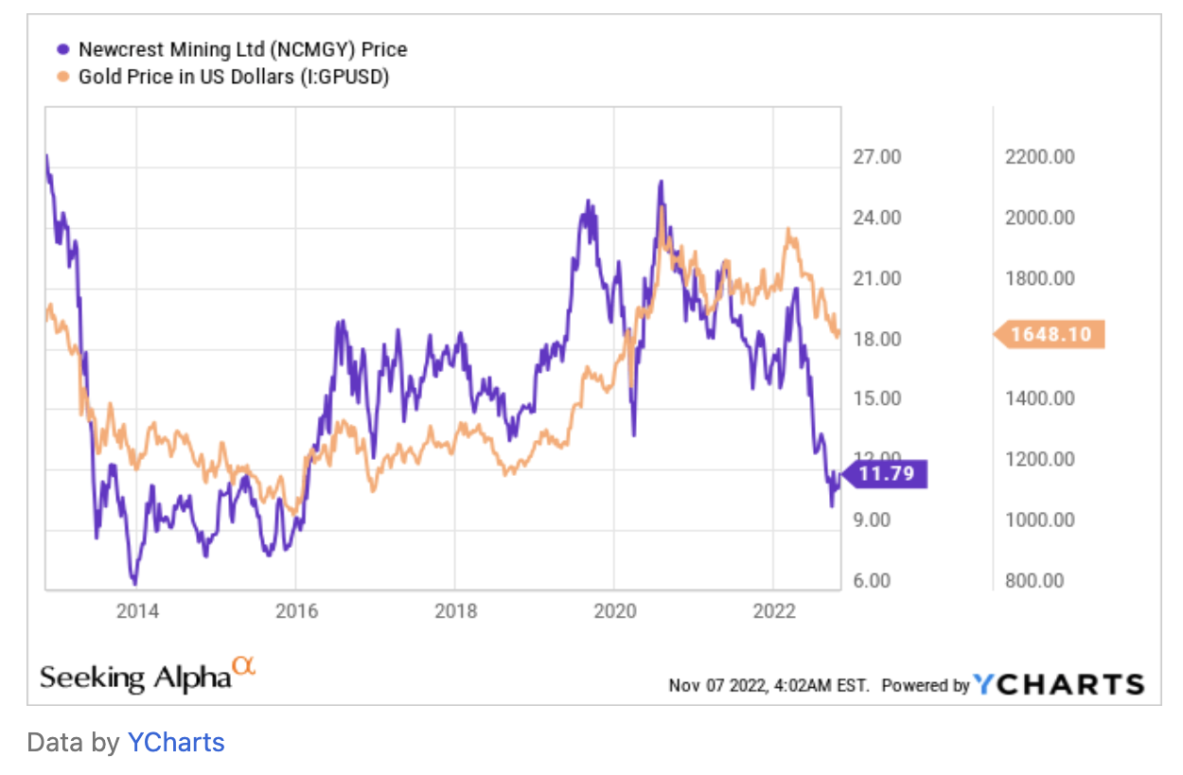
High inflation often leads people to view gold as a safeguard. Gold is commonly regarded as a defensive asset that can offer stability when compared to volatile investments such as stocks and real estate, especially during times of economic uncertainty. However, during periods of economic recovery and optimism, investors often prioritize risk assets such as stocks and property over safe-haven assets like gold. This preference for risk assets can lead to a decrease in demand for gold stocks, including Newcrest Mining- a prominent player in the gold mining industry.

Nevertheless, some analysts believe that gold stocks may be poised for a turnaround, considering factors such as peak inflation and a potential shift in the Federal Reserve's policy stance. Investors are contemplating whether now is the right time to invest in gold stocks, as they offer potential as an inflation hedge and defensive asset class. Analysts suggest that gold stocks, including Newcrest Mining, may be undervalued and present an interesting opportunity for investors (F Saleem 2023).
Also, The price of gold has a positive impact on the stock price due to increased revenue and profitability. Higher gold prices offset production costs and attract investor sentiment as a safe-haven investment.

A comprehensive financial analysis was conducted, including a valuation of Newcrest Mining by forecasting future free cash flow and using the WACC method to determine their present value -which was used for investors to see how much interest the company has to pay for every dollar it finances. Additionally, the analysis included a sensitivity analysis to assess potential risks and uncertainties.
Based on the valuation and sensitivity analysis, it is recommended that prospective investors consider Newcrest Mining as a favorable investment opportunity. In light of the fluctuation of gold price and market position , fundamental issues (declining profit margins and earnings per share) and our own valuations, our advice to any prospective investors would be to sell rather than to buy.

INTRODUCTION: Company Profile

History and Main Products
Newcrest Mining Limited is a prominent Australian-based mining corporation specializing in gold exploration, development, and mining.The company's headquarters are located in Melbourne, Australia and has a diverse portfolio of mining operations across multiple regions. In Australia, Newcrest operates the Cadia Valley Operations, which include the Cadia East Ridgeway mine and the Telfer Mine in the Pilbara region of Western Australia. Additionally, Newcrest has mines in Papua New Guinea, namely the Lihir mine on Lihir Island and the Hidden Valley mine in Morobe Province. The company also operates mines in Canada, including the Red Chris mine and the Brucejack mine.
The company's roots trace back to Newmont Mining Corporation, which was established in 1921 in New York. Newmont began its Australian subsidiary in 1966 and eventually transformed into Newmont Holdings Pty Ltd before acquiring Australmin Holdings Ltd and BHP Gold Mines Ltd, leading to the current name of Newcrest Mining Limited. The company has been actively involved in mergers and acquisitions to expand its operations. In 2010, Newcrest announced a merger with Lihir Gold, creating one of the world's largest gold producers. In recent years, there have been takeover offers for Newcrest, including a rejected offer from Newmont Mining Corporation in 2023 and an accepted revised offer in May 2023.
Newcrest Mining Limited has continued to expand its operations through strategic acquisitions, such as the acquisition of the Red Chris operation in a joint venture with Imperial Metals in 2019 and the acquisition of Pretium Resources Inc., including the Brucejack operation, in 2022. These acquisitions have further strengthened Newcrest's position as a leading global mining company.

ANALYSIS AND DISCUSSION

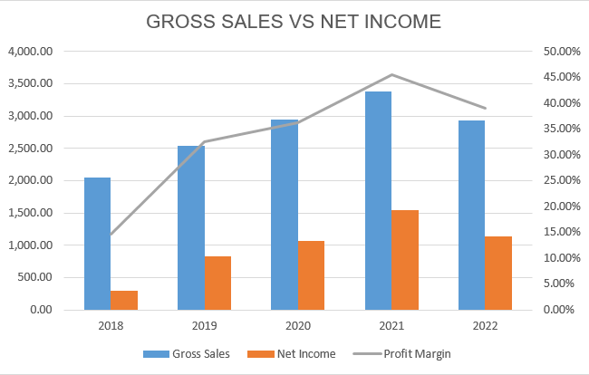
Gross Sales vs Net Income

Figure 1: Newcrest Mining Limited’s gross sales vs net income
When comparing gross sales to net income, Newcrest Mining Limited's financial performance throughout the five years from 2018 to 2022 shows an intriguing trend. The business had $2,052.10 million in gross sales in 2018. Over the ensuing years, this amount grew rapidly, reaching $3,382.30 million in 2021. Nonetheless, the net income also showed a good trend throughout this same time frame, rising from $299.95 million in 2018 to $1,540.84 million in 2021. This illustrates how well the business is able to turn a sizable percentage of its gross sales into profit. Remarkably, there was a steady increase in the profit margin—that is, the proportion of sales that result in profit—which peaked in 2021 at 45.56%. This suggests that Newcrest Mining Limited has achieved a high profitability ratio as a consequence of effectively controlling its operating expenses and maximising its revenue generation. Despite a minor decline in gross sales to $2,930.20 million in 2022, the business was still able to keep a healthy profit margin of 39.00%. This demonstrates the flexibility of Newcrest Mining Limited's business model, which prioritises efficiency and profitability, and its capacity to adjust to shifting market conditions without compromising its ability to provide shareholders with strong returns.

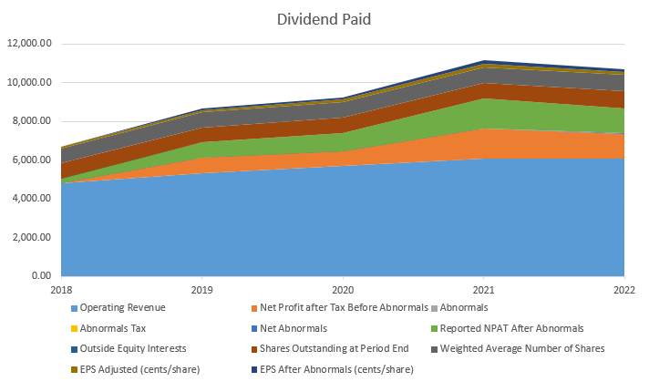
Dividend Payment

Over the five years from 2018 to 2022, Newcrest Mining Limited, a well-known participant in the mining sector, demonstrated notable financial growth and durability. Through an examination of important financial indicators such as revenue growth, profitability, the effect of abnormal items, earnings per share (EPS), and changes in the number of outstanding shares, this essay seeks to present a thorough study of Newcrest Mining Limited's financial performance.
During the designated period, Newcrest Mining Limited saw a significant increase in revenue. From over $4.82 billion in 2018 to an impressive $6.11 billion in 2022, operating revenue increased. There are several possible reasons for this strong rise, such as rising commodity prices, increasing production levels, or expanding markets.
The steadily rising profitability is one of the most notable features of Newcrest Mining Limited's financial performance. In 2022, the net profit after tax, exclusive of anomalous items, more than doubled to $1.23 billion from $594 million in 2018. This shows that the company's bottom line has benefited greatly from better operational efficiency and effective cost management.
The impact of anomalous items is a fascinating aspect of Newcrest Mining Limited's financial path. In 2018 and 2020, abnormal items had a negative impact on the company's finances. What is noteworthy, though, is how the business was able to bounce back from these losses in the years that followed. This capacity to take in and recover from unusual costs demonstrates adaptation and resilience in the face of unforeseen financial difficulties.
One important indicator of a company's financial performance is earnings per share (EPS). With atypical items removed, the adjusted EPS increased steadily from 75.81 cents in 2018 to an astounding 145.71 cents in 2022. The EPS showed notable growth as well, rising from 35.45 cents in 2018 to 149.66 cents in 2022 after accounting for anomalous items. This demonstrates Newcrest Mining Limited's steadfast dedication to generating profits growth that will provide value for its investors.
The company's approach to lessen the effects of unusual expenses is further demonstrated by the decline in unusual tax items over time. This calculated action demonstrates the company's attempts to reduce the negative financial impacts of anomalous goods, which in turn boosts its overall profitability.
An important consideration for shareholders is the rise in the number of outstanding shares over the course of the five-year term. The increasing number of outstanding shares suggests that ownership may be diluted, which may have an impact on current shareholders' ownership holdings and possible dilution effects. This dynamic highlights how crucial it is to keep an eye on how changes in the company's capital structure are affecting things.

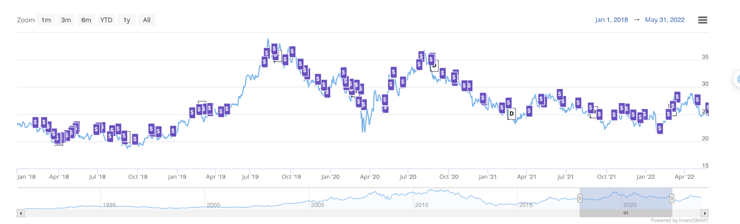
Stock Price Movement

Starting in 2018, the stock experienced a period of volatility, with significant fluctuations in price. It reached a peak of $38.87 in mid-2019 followed by a sharp decline to $28.05 towards the end of the year. However, the COVID-19 pandemic had a notable impact on the stock, causing a significant decline to $21.74 in March 2020. As global markets recovered, Newcrest Mining's stock also rebounded and entered a period of relative stability throughout 2020 and 2021. The stock price generally moved within a range of $20 to $27 during this time, with occasional minor fluctuations. It's worth noting that Newcrest Mining paid dividends during this period, with an average annual dividend yield of 2.5%, which likely influenced the overall return for investors. The stock experienced a gradual decline in early 2021, reaching a low point in November. However, there was a subsequent recovery, and the stock price started to climb again. Overall, the stock's performance during the analyzed period was influenced by a combination of global economic conditions, industry-specific factors, and company-specific news.

Capital Structure
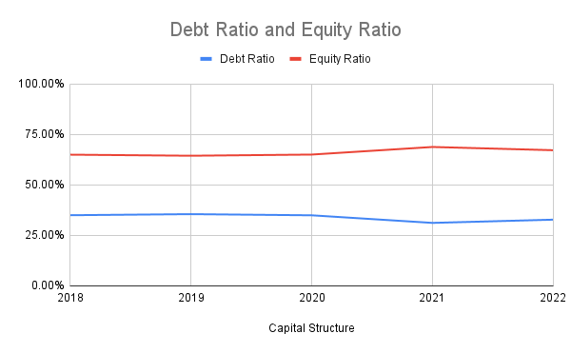
Capital structure provides valuable insights into its financial risk, ability to meet obligations, growth strategy, and overall financial health. It assists investors, stakeholders, and management in making informed decisions regarding investment, financing, and risk management strategies.

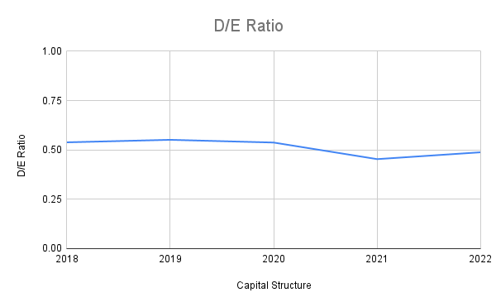
From 2018 to 2022, the company maintained a relatively stable debt ratio, ranging from 31.20% to 35.53%. Notably, the debt ratio decreased in 2021, suggesting a reduction in debt liabilities during that period. Furthermore, Newcrest Mining demonstrated a gradually increasing equity ratio, ranging from 64.47% to 68.80% over the years. This indicates a growing proportion of assets being financed through equity, which can enhance the company's financial stability and reduce financial risk.

Examining the debt-to-equity (D/E) ratio, Newcrest Mining showcased a consistent and reasonable level of debt relative to its equity. The D/E ratio ranged from 0.45 to 0.55, indicating a relatively low reliance on debt financing compared to equity. This implies a stable financial position and may attract investors looking for companies with sound financial management.

Global Gold Price from 2018-2022
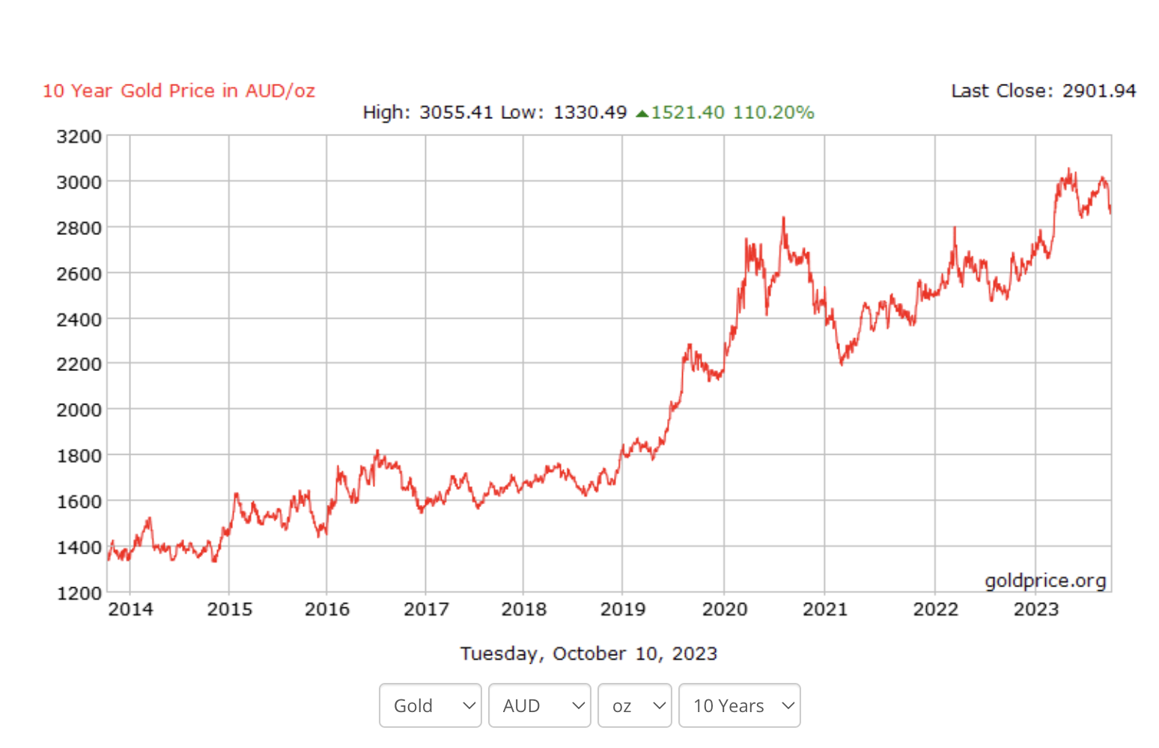
A higher gold price generally leads to improved profitability and cash flow, allowing the company to pay down debt and reduce its debt levels, thereby lowering the D/E ratio. Research has found that the gold price had risen at the end of 2019 after a decrease in earlier years which compensated the previous loss immediately.
Overall, the capital structure analysis of Newcrest Mining indicates that the company has maintained a relatively stable and balanced capital structure. The company has gradually increased its total assets and total equity, while the debt ratio and D/E ratio have remained within reasonable ranges. This suggests that Newcrest Mining has been able to finance its operations and investments through a mix of debt and equity, while maintaining a solid financial position.

Weighted Average Cost of Capital (WACC)
The Weighted Average Cost of Capital (WACC) is a critical financial metric used by businesses to determine the cost of capital required to fund their operations and investment projects. It represents the blended cost of debt and equity financing used by a company, taking into account their respective weights in the capital structure. WACC is a fundamental tool for assessing the attractiveness of potential investments, as it serves as the discount rate in financial valuation models like the discounted cash flow analysis.Estimating Newcrest Mining's Weighted Average Cost of Capital (WACC) provides valuable insight into the company's financing costs. By calculating the WACC, investors can assess how efficiently the company is utilizing its financial resources.

- Beta:
For Newcrest Mining, the equity beta of 0.73 implies that its stock price is moderately sensitive to market fluctuations, indicating a moderate level of equity risk compared to the broader market. The asset beta, at 0.347, reflects the company's overall business risk, which is notably lower than its equity risk, suggesting that factors beyond market movements, such as industry-specific dynamics, may contribute to the company's risk profile. Furthermore, the debt beta of 0.083 suggests that Newcrest Mining's debt structure has relatively low volatility compared to the market, indicating a lower level of specific risk associated with its debt financing. These beta values collectively help investors and analysts assess the company's risk exposure and make informed decisions regarding investments in Newcrest Mining.
- Newcrest Mining Ltd cost of equity and cost of debt
For Newcrest Mining Ltd, a leading mining company in the resource sector, the Weighted Average Cost of Capital (WACC) is a pivotal financial metric used to evaluate the cost of capital required for financing its operations and investment projects. The company's capital structure is primarily composed of equity and debt, with equity comprising 82.62% and debt 17.38% of the total capital. Newcrest's cost of debt is approximately 0.6857 (68.57%), while the cost of equity stands at 0.4206 (42.06%). When these factors are weighted accordingly, the calculated WACC is approximately 46.68%, suggesting the rate at which the company should discount future cash flows to evaluate the attractiveness of its investment opportunities. This WACC, higher than the initially mentioned 43.09%, indicates that Newcrest Mining faces a relatively higher cost of capital, which is essential information for the company's financial decision-making and investment valuation processes.
Newcrest Mining's Return on Invested Capital (ROIC) of 4.44% is a critical indicator of the company's ability to generate returns from the capital invested in its operations. To assess its performance, we can compare this ROIC to the Weighted Average Cost of Capital (WACC). With a calculated WACC of 46.68%, the ROIC of 4.44% is significantly lower, indicating that Newcrest Mining is not generating returns in excess of its cost of capital. This suggests that the company may be facing challenges in delivering substantial value to its investors. It is essential for Newcrest to improve its ROIC and bring it closer to or above its WACC to ensure that its investments are yielding a competitive return and creating value for shareholders.

Forecasting future financial performance
Financial forecasting involves predicting a company's future financial performance, encompassing revenue, expenses, profitability, and cash flow. While essential for planning and decision-making, forecasting faces challenges like inherent uncertainty, data quality, assumption bias, complexity, external factors, and model selection. These complexities underscore the importance of regularly updating forecasts, using a combination of quantitative and qualitative methods, and ensuring effective communication to manage expectations and adapt to changing circumstances. Despite these challenges, financial forecasting remains a critical tool for informed financial planning, risk management, and strategic decision-making.
The provided valuation using the CAGR-based forecast and the Weighted Average Cost of Capital (WACC) offers an optimistic perspective on Newcrest Mining Ltd. The use of a CAGR to smooth out outlier data, like the substantial revenue of 2022, while a valid technique for forecasting, may not adequately address the complexities and uncertainties inherent in the mining industry. A WACC of 43.09% is notably high, suggesting a substantial cost of capital, and this might not account for certain risks unique to the mining sector. Furthermore, the share price of $21 is relatively low in comparison to the calculated NPV $410,356,960, raising questions about market dynamics and whether this valuation adequately considers the company's risks, growth prospects, and the broader economic context.
Firm FCF is a comprehensive measure that takes into account cash flows available to both equity and debt holders. The projection of Firm FCF, with figures ranging from $1,982.09 million in 2023 to $6,368.63 million in 2028, demonstrates the company's ability to generate cash that benefits all investors. However, the calculated Weighted Average Cost of Capital (WACC) of 43.09% raises concerns. This high WACC translates to a substantial discount rate, which could diminish the present value of anticipated cash flows, consequently impacting the NPV.
Equity FCF, representing the cash flows available to equity investors, also exhibits positive growth prospects, with projections from $1,387.06 million in 2023 to $1,653.98 million in 2028. The choice of a Compound Annual Growth Rate (CAGR)-based forecast, aimed at smoothing outliers and providing methodical projections, offers a systematic approach. However, it's essential to scrutinize whether these projections accurately reflect the company's potential fluctuations and uncertainties, particularly within the dynamic mining industry. Therefore, the promising valuation must be approached with caution. A thorough risk assessment, taking into consideration market sentiment, industry-specific risks, and the company's long-term outlook, is imperative.
With above reasons to exercise caution and consider, our analysis indicates that Newcrest Mining Ltd is ultimately deemed to be overvalued, and unless significant changes occur, a market correction is expected to rectify this situation.

CONCLUSION
Our analysis of Newcrest Mining Limited reveals a company with a rich history and a strong financial performance. Newcrest has consistently converted a significant portion of its gross sales into profit, with a steady increase in profit margin. The company's consistent dividend payments and strong revenue growth showcase its financial strength.
However, our valuation based on Compound Annual Growth Rate (CAGR) projections and a high Weighted Average Cost of Capital (WACC) suggests caution. While Newcrest's future cash flows look promising, the high WACC raises concerns about valuation accuracy.
In light of these complexities and risks, our analysis suggests that Newcrest Mining Ltd may be overvalued. We recommend potential investors exercise caution, conduct a thorough risk assessment, and closely monitor market dynamics before considering an investment.

RECOMMENDATIONS
For potential investors, a cautious approach is advised when considering Newcrest Mining Ltd. The mining industry carries inherent risks, and the high WACC should be carefully considered. Conducting a comprehensive risk assessment, staying informed about market trends and industry-specific risks, and regularly updating financial forecasts are essential.
While Newcrest Mining presents potential investment opportunities, a thorough understanding of the industry's challenges and the company's ability to generate returns above its cost of capital is crucial. Stay vigilant, and make informed investment decisions in line with your risk tolerance and financial goals.

REFERENCES
Sokolidou, A 2022, ‘Newcrest mining: Undervalued stock in a future Star Industry (NCMGY)’, Seeking Alpha, viewed October 10 2023, <https://seekingalpha.com/article/4554725-newcrest-mining-limited-an-undervalued-stock >.
Saleem, F 2023, ‘11 most undervalued gold stocks to buy according to hedge funds’, Yahoo! Finance, viewed October 14 2023, <https://finance.yahoo.com/news/11-most-undervalued-gold-stocks-153113339.html >
‘Newcrest Mining Limited (ASX:NCM)’ Intelligent Investor, viewed October 19 2023, <https://www.intelligentinvestor.com.au/shares/asx-ncm/newcrest-mining-limited/share-price?from=01%2F01%2F2018&To=31%2F12%2F2022&size=50&page=1 >.

APPENDIX
APPENDIX 1:
PROFIT AND LOSS
($ millions) | 2018 | 2019 | 2020 | 2021 | 2022
Operating Revenue | 4,819.00 | 5,335.00 | 5,714.00 | 6,086.00 | 6,106.00
Other Revenue | 223.24 | 61.31 | 94.71 | 321.89 | 307.74
Total Revenue Excluding Interest | 5,042.00 | 5,397.00 | 5,809.00 | 6,408.00 | 6,414.00
Operating Expenses | -3,064.00 | -3,015.00 | -3,032.00 | -3,148.00 | -3,466.00
EBITDA | 1,978.00 | 2,381.00 | 2,777.00 | 3,260.00 | 2,948.00
Depreciation | -1,044.00 | -1,063.00 | -938.37 | -895.18 | -1,064.00
Amortisation | -25.71 | 0.00 | 0.00 | 0.00 | -24.68
Depreciation and Amortisation | -1,070.00 | -1,063.00 | -938.37 | -895.18 | -1,088.00
EBIT | 907.86 | 1,317.00 | 1,838.00 | 2,364.00 | 1,859.00
Interest Revenue | 10.82 | 37.07 | 27.68 | 35.91 | 36.29
Interest Expense | -165.07 | -171.11 | -276.85 | -171.59 | -145.16
Net Interest Expense | -154.24 | -134.04 | -249.16 | -135.67 | -108.87
PreTax Profit | 753.62 | 1,183.00 | 1,589.00 | 2,229.00 | 1,750.00
Tax Expense | -159.65 | -387.85 | -492.50 | -670.39 | -518.22
Net Profit after Tax Before Abnormals | 593.97 | 795.67 | 1,097.00 | 1,558.00 | 1,232.00
Abnormals | -311.19 | 0.00 | -154.45 | -10.64 | 33.39
Abnormals Tax | 0.00 | 0.00 | -17.49 | 0.00 | 0.00
Net Abnormals | -311.19 | 0.00 | -171.94 | -10.64 | 33.39
Reported NPAT After Abnormals | 282.78 | 795.67 | 925.25 | 1,548.00 | 1,265.00
Outside Equity Interests | -9.47 | 4.28 | 17.49 | 0.00 | 0.00
Shares Outstanding at Period End | 766.61 | 768.48 | 813.82 | 814.75 | 893.12
Weighted Average Number of Shares | 767.41 | 768.20 | 776.05 | 816.72 | 842.97
EPS Adjusted (cents/share) | 75.81 | 103.81 | 143.17 | 190.31 | 145.71
EPS After Abnormals (cents/share) | 35.45 | 103.81 | 121.08 | 189.01 | 149.66
APPENDIX 2:
Profit Margin = $\frac{Net Income}{Gross Sales}$
($ millions) | 2018 | 2019 | 2020 | 2021 | 2022
Gross Sales | 2,052.10 | 2,546.30 | 2,947.60 | 3,382.30 | 2,930.20
Net Income | 299.95 | 830.06 | 1,067.15 | 1,540.84 | 1,142.82
Profit Margin | 14.62% | 32.60% | 36.20% | 45.56% | 39.00%

Capital Structure

Ratio analysis of Newcrest Mining Limited from 2018-2022

Debt Ratio = $\frac{Total Liabilities}{Total Liabilities + Total Equity}= \frac{Total Liabilities}{Total Assets}$

Equity = $\frac{Total Equity}{Total Liabilities + Total Equity}= \frac{Total Equity}{Total Assets}$

D/E Ratio = $\frac{Total Liabilities}{Total Equity}$

Capital Structure | 2018 | 2019 | 2020 | 2021 | 2022
Total Assets | 15.538 | 16.868 | 19.233 | 19.599 | 25.244
Total Liabilities | 5.438 | 5.994 | 6.723 | 6.114 | 8.28
Total Equity | 10.099 | 10.874 | 12.510 | 13.485 | 16.964
Debt Ratio | 35.00% | 35.53% | 34.96% | 31.20% | 32.80%
Equity Ratio | 65.00% | 64.47% | 65.04% | 68.80% | 67.20%
D/E Ratio | 0.54 | 0.55 | 0.54 | 0.45 | 0.49

APPENDIX 3:
 | Average of Capital structure 2018-2022 | Weight | Cost | WACC
Long-term Liabilites | 2,682.98 | 0.17 | 0.6857 | 0.08344382494
Stock | 12,750.20 | 0.83 | 0.4205775964 | 0.3474623162
Total Market value | 15,433.18 |  |  | 0.4309061412

Date | Market Index ( All Ordinaries) | ShareR | rf | rm | rj | (rm-Rf) | (rj-Rf)
Jan-18 | 6,117 | 19.0439 | 0.2263
Feb-18 | 5,869 | 17.5294 | 0.2353 | -4.0606 | -7.9529 | -4.2959 | -8.1882
Mar-18 | 6,072 | 19.0487 | 0.2239 | 3.4538 | 8.6669 | 3.2299 | 8.4430
Apr-18 | 6,124 | 18.6974 | 0.2255 | 0.8548 | -1.8440 | 0.6293 | -2.0695
May-18 | 6,290 | 19.6341 | 0.2296 | 2.7141 | 5.0096 | 2.4845 | 4.7800
Jun-18 | 6,366 | 19.4810 | 0.2223 | 1.2163 | -0.7798 | 0.9940 | -1.0021
Jul-18 | 6,428 | 17.4635 | 0.2174 | 0.9676 | -10.3560 | 0.7502 | -10.5734
Aug-18 | 6,326 | 17.6165 | 0.2133 | -1.5915 | 0.8762 | -1.8048 | 0.6629
Sep-18 | 5,913 | 18.7056 | 0.2166 | -6.5165 | 6.1824 | -6.7331 | 5.9658
Oct-18 | 5,749 | 18.8327 | 0.2206 | -2.7734 | 0.6793 | -2.9940 | 0.4587
Nov-18 | 5,709 | 19.7857 | 0.2206 | -0.6940 | 5.0602 | -0.9146 | 4.8396
Dec-18 | 5,937 | 22.1908 | 0.2003 | 3.9917 | 12.1560 | 3.7914 | 11.9557
Jan-19 | 6,253 | 22.0728 | 0.1872 | 5.3122 | -0.5317 | 5.1250 | -0.7189
Feb-19 | 6,262 | 23.2504 | 0.1758 | 0.1439 | 5.3348 | -0.0319 | 5.1590
Mar-19 | 6,418 | 22.7947 | 0.1619 | 2.5025 | -1.9600 | 2.3406 | -2.1219
Apr-19 | 6,492 | 24.7998 | 0.1537 | 1.1436 | 8.7965 | 0.9899 | 8.6428
May-19 | 6,699 | 29.1199 | 0.1365 | 3.1948 | 17.4201 | 3.0583 | 17.2836
Jun-19 | 6,897 | 32.4284 | 0.1143 | 2.9481 | 11.3615 | 2.8338 | 11.2472
Jul-19 | 6,698 | 33.7226 | 0.1085 | -2.8782 | 3.9910 | -2.9867 | 3.8825
Aug-19 | 6,801 | 31.8672 | 0.0788 | 1.5288 | -5.5019 | 1.4500 | -5.5807
Sep-19 | 6,773 | 28.7034 | 0.0854 | -0.4073 | -9.9280 | -0.4927 | -10.0134
Oct-19 | 6,948 | 28.2082 | 0.0854 | 2.5853 | -1.7252 | 2.4999 | -1.8106
Nov-19 | 6,802 | 27.7405 | 0.0953 | -2.0956 | -1.6580 | -2.1909 | -1.7533
Dec-19 | 7,121 | 27.0803 | 0.0995 | 4.6866 | -2.3802 | 4.5871 | -2.4797
Jan-20 | 6,512 | 24.1182 | 0.0953 | -8.5618 | -10.9380 | -8.6571 | -11.0333
Feb-20 | 5,111 | 21.2230 | 0.0813 | -21.5142 | -12.0041 | -21.5955 | -12.0854
Mar-20 | 5,598 | 25.3572 | 0.0739 | 9.5312 | 19.4794 | 9.4573 | 19.4055
Apr-20 | 5,872 | 28.1562 | 0.0714 | 4.9038 | 11.0385 | 4.8324 | 10.9671
May-20 | 6,001 | 29.0309 | 0.0755 | 2.1985 | 3.1066 | 2.1230 | 3.0311
Jun-20 | 6,058 | 32.3916 | 0.0763 | 0.9498 | 11.5763 | 0.8735 | 11.5000
Jul-20 | 6,246 | 29.4268 | 0.0730 | 3.0966 | -9.1529 | 3.0236 | -9.2259
Aug-20 | 6,009 | 28.9762 | 0.0739 | -3.7881 | -1.5312 | -3.8620 | -1.6051
Sep-20 | 6,133 | 27.1212 | 0.0747 | 2.0618 | -6.4020 | 1.9871 | -6.4767
Oct-20 | 6,742 | 24.9786 | 0.0681 | 9.9279 | -7.9001 | 9.8598 | -7.9682
Nov-20 | 6,851 | 23.9119 | 0.0722 | 1.6093 | -4.2703 | 1.5371 | -4.3425
Dec-20 | 6,871 | 23.2997 | 0.0813 | 0.2963 | -2.5601 | 0.2150 | -2.6414
Jan-21 | 6,941 | 22.8545 | 0.0871 | 1.0144 | -1.9108 | 0.9273 | -1.9979
Feb-21 | 7,017 | 22.8302 | 0.1093 | 1.1008 | -0.1064 | 0.9915 | -0.2157
Mar-21 | 7,291 | 24.7935 | 0.1398 | 3.9005 | 8.5995 | 3.7607 | 8.4597
Apr-21 | 7,407 | 26.4763 | 0.1365 | 1.5911 | 6.7873 | 1.4546 | 6.6508
May-21 | 7,585 | 23.6342 | 0.1340 | 2.4073 | -10.7345 | 2.2733 | -10.8685
Jun-21 | 7,664 | 24.7654 | 0.1258 | 1.0442 | 4.7864 | 0.9184 | 4.6606
Jul-21 | 7,823 | 23.1294 | 0.1036 | 2.0759 | -6.6063 | 1.9723 | -6.7099
Aug-21 | 7,630 | 21.6391 | 0.0929 | -2.4747 | -6.4432 | -2.5676 | -6.5361
Sep-21 | 7,639 | 23.7896 | 0.1060 | 0.1232 | 9.9382 | 0.0172 | 9.8322
Oct-21 | 7,587 | 22.5758 | 0.1422 | -0.6768 | -5.1024 | -0.8190 | -5.2446
Nov-21 | 7,779 | 23.3977 | 0.1496 | 2.5279 | 3.6410 | 2.3783 | 3.4914
Dec-21 | 7,268 | 20.5973 | 0.1332 | -6.5675 | -11.9690 | -6.7007 | -12.1022
Jan-22 | 7,323 | 24.5351 | 0.1553 | 0.7553 | 19.1183 | 0.6000 | 18.9630
Feb-22 | 7,790 | 25.6625 | 0.1742 | 6.3688 | 4.5949 | 6.1946 | 4.4207
Mar-22 | 7,725 | 25.7969 | 0.2060 | -0.8319 | 0.5236 | -1.0379 | 0.3176
Apr-22 | 7,455 | 24.0310 | 0.2474 | -3.4901 | -6.8452 | -3.7375 | -7.0926
May-22 | 6,747 | 20.0482 | 0.2774 | -9.5061 | -16.5735 | -9.7835 | -16.8509
Jun-22 | 7,174 | 18.5223 | 0.3089 | 6.3337 | -7.6113 | 6.0248 | -7.9202
Jul-22 | 7,226 | 17.0156 | 0.2806 | 0.7290 | -8.1347 | 0.4484 | -8.4153
Aug-22 | 6,679 | 16.4927 | 0.2766 | -7.5753 | -3.0729 | -7.8519 | -3.3495
Sep-22 | 7,055 | 16.9118 | 0.3064 | 5.6313 | 2.5414 | 5.3249 | 2.2350
Oct-22 | 7,481 | 19.3097 | 0.3209 | 6.0370 | 14.1787 | 5.7161 | 13.8578
Nov-22 | 7,222 | 20.1187 | 0.3040 | -3.4622 | 4.1898 | -3.7662 | 3.8858
Dec-22 | 7,686 | 21.7466 | 0.2927 | 6.4306 | 8.0911 | 6.1379 | 7.7984
 |  | Average | 0.1610 | 0.5157

Standard Deviation | 4.9639 | 8.3546
Variance | 24.6402 | 69.7986
Correlation | 0.4348
Beta | 0.7319
APPENDIX 4:
Firm FCF

 | 2023 | 2024 | 2025 | 2026 | 2027 | 2028
Net operating income | 873.51 | 862.82 | 850.24 | 835.57 | 818.59 | 799.05
Less: Taxes on operating income | 262.05 | 258.85 | 255.07 | 250.67 | 245.58 | 239.71
NOPAT | 611.46 | 603.98 | 595.17 | 584.90 | 573.01 | 559.33
Increase/Decrease deferred taxes | 929.90 | 1,192.10 | 1,528.22 | 1,959.12 | 2,511.51 | 3,219.66
Plus: Depreciation | 1,054.64 | 1,062.75 | 1,070.92 | 1,079.15 | 1,087.44 | 1,095.80
Less: CAPEX | -865.42 | -877.54 | -889.64 | -901.71 | -913.77 | -925.81
Less: Change in operating net working capital | 251.51 | 398.03 | 628.32 | 988.30 | 1,548.89 | 2,419.64
Firm free cash flow from operations | 1,982.09 | 2,379.31 | 2,932.99 | 3,709.76 | 4,807.09 | 6,368.63
Non-operating income after taxes | -62.83 | 58.43 | -54.35 | 50.55 | -47.01 | 43.72
Free cash flow available for investors | 1,919.26 | 2,437.74 | 2,878.64 | 3,760.31 | 4,760.08 | 6,412.35

Equity FCF

 | 2023 | 2024 | 2025 | 2026 | 2027 | 2028
Net income | 459.47 | 579.68 | 461.12 | 558.33 | 451.36 | 530.82
Plus: depreciation | 1,054.64 | 1,062.75 | 1,070.92 | 1,079.15 | 1,087.44 | 1,095.80
Increase/decrease in long-term debts | 35.29 | 35.75 | 36.22 | 36.70 | 37.18 | 37.67
Increase/decrease in short-term debts | 24.69 | 33.61 | 45.76 | 62.30 | 84.82 | 115.48
Increase/decrease in deferred income tax | 929.90 | 1,192.10 | 1,528.22 | 1,959.12 | 2,511.51 | 3,219.66
Less: change in operating NWC | 251.51 | 398.03 | 628.32 | 988.30 | 1,548.89 | 2,419.64
Less: CAPEX | -865.42 | -877.54 | -889.64 | -901.71 | -913.77 | -925.81
Equity FCF | 1,387.06 | 1,628.33 | 1,624.29 | 1,805.59 | 1,709.67 | 1,653.98

TCF and NPV

TCF | 2023 | 2024 | 2025 | 2026 | 2027 | 2028
Firm free cash flow from operations | 1,982.09 | 2,379.31 | 2,932.99 | 3,709.76 | 4,807.09 | 6,368.63 |  | TCF
 |  | 0.2004036783 | 0.2327075186 | 0.2648385152 | 0.2957950666 | 0.324841114 | 0.2637171785 | 48138.03
Non operating income after taxes | -62.83 | 58.43 | -54.35 | 50.55 | -47.01 | 43.72
 |  | -1.930073606 | -1.930073606 | -1.930073606 | -1.930073606 | -1.930073606 | -1.930073606 | -17.22
 | 1385.199406 | 1162.05977 | 1001.099775 | 884.9144723 | 801.3578071 | 741.9576584 |  | 413195.12
 | -43.90677368 | 28.53893079 | -18.54999815 | 12.05729934 | -7.837114929 | 5.094040437 |  | -147.85

NPV
410356.96

