Bond yields represent how much investors expect to receive from holding a bond over its term to maturity, credit risk, and prevailing economic conditions. During various maturities, yield curves will form, and they are a valuable tool for investors to gauge market expectations. A standard and upward-sloping yield curve means that long-term bonds have higher yields over time to compensate for changes like inflation and interest rates. However, when the economy experiences uncertainty, the yield curve may invert or flatten, signaling shifting investor outlooks and potential economic contraction.

This report will compare three bonds, which are an Nvidia corporate bond (67066GAE4), a US Treasury bond (9128283W81), and an Australian government bond (AU000GSBU292). There is a contrast between the Nvidia's bond as corporate bonds have higher credit risk than the US and Australian government bonds, which have low risk due to government backing. This comparison shows how credit risk, bond structure, and issuer type impact bond yields.

We will explore the primary drivers of these bond yields and examine how macroeconomic factors, such as inflation, interest rates, and economic growth expectations, influence yields and prices across these different bond types (US Department of the Treasury).

Throughout the years, the US government has always been the world's largest sovereign debt issuer, and its enduring reputation for financial stability attracts many investors around the world. US treasury bonds are often rated AA+ and perceived as risk-free, with the US dollar as the global reserve currency. This makes the Treasuries a benchmark in global finance, influencing rates on various financial instruments worldwide.

The 10-year bond selected in the report (US9128283W81), issued on February 15, 2018, has a 2.75% coupon rate paid semi-annually. With a face value of $100, this type of bond provides steady returns with high liquidity of US treasuries, so it's easy to trade, especially for those seeking a stable and secure investment. Investors tend to accept lower yields since it will have a stable income stream related to minimal risk, which makes it ideal for those who want to balance their portfolio if they have riskier investments.

Like the US government, Australia is a highly trusted sovereign issuer with a AAA rating that reflects stable economic fundamentals. Australian government bonds are denominated in Australian dollars, so investors outside Australia may face currency risk. However, this type of bond is a good choice for those seeking exposure in the Asia-Pacific region since it offers both security and the benefit of regional diversification.

The 10-year bond selected in the report (AU000GSBU292) was issued in January 2018, with a 2.75% coupon paid every six months. Although the structure is similar to the US Treasury, its yield is a little higher due to currency fluctuations and the influence of the commodity market on the economy.

This report used Nvidia Corporation's bond for comparison since there has been a trend in graphics processing units and artificial intelligence, and this company is the global leader in this field. Nvidia has a strong market position and operates in a highly competitive tech industry subject to economic fluctuations and rapid innovation cycles. By that, this sector's inherent volatility and exposure to global supply chains introduce potential risks. These market dynamics influence the credit risk in this corporate bond, balancing the reputation for innovation with the industry's uncertainties.

The 10-year bond selected in the report (67066GAE4) was issued on September 16, 2016, with a coupon rate of 3.20% paid semi-annually, denominated in US dollars. A unique thing is that this bond has a call option, which means Nvidia can redeem it before maturity. Moreover, this bond has higher yields than government bonds to compensate for this sector's credit risk and volatility. With a minimum of 2000 tradeable units, it targets institutional and retail investors seeking diversification and high returns.

Although US bonds are considered safe, macroeconomic conditions can shape the yields and prices. Some critical drivers of fluctuations included the Federal Reserve's interest rate policies, inflation expectations, and global economic events.

In late 2018, with a low unemployment rate and a strong economy, the Federal Reserve raised the interest rate four times. This rate increased yields on new issue bonds, making older bonds less attractive and causing a price fall (Stawasz Grabowska and Wieloch, 2023). By mid-2019, the trade war between the US and China forced the Federal Reserve to cut the rate, which strengthened the economic uncertainty but reduced foreign investment at the same time. This policy reversal pushed the price higher with the investor's expectation for safe-haven assets, reducing the yields significantly.

In early 2020, COVID-19 broke out and significantly impacted the global economy, with a sharp rise in unemployment rate and market volatility. To deal with the situation, the US government has given out various monetary policies, such as the Care Act. Moreover, the Federal Reserve also reduced the interest rate to -0.25%. The increase in economic market risk increases the need for a stable investment with less risk related to interest rates. Because of that, there is an upward trend in bond prices while the yield plummeted (Alkhataybeh 2022) .

By 2021, the economy began to recover with vaccination rollouts, and fiscal stimulus made the GDP grow rapidly, which increased inflation expectations. The Federal Reserve hesitated to tighten policy at first but then raised the interest rate seven times to 2022 to fight back the inflation (Van Lear, 2024). These hikes increased yield and declined bond prices, as some investors wanted to profit by selling. This trend lasted to 2023, as the Fed maintained rates around 5% amid persistent inflation and slowing economic growth.

The conflict between Russia and Ukraine can also impact treasury bond yields, with the worsening in energy price inflation and issues with the supply chain. While the US government typically acts as a haven during geopolitical tensions, inflationary pressures have offset some of these effects, keeping yields elevated.

Looking forward, the US bond prices remain sensitive to the interplay between inflation expectations, Federal Reserve policy, and economic growth prospects. A slowing US economy could renew demand for stabilizing bond prices, but persistent inflation or further rate hikes would likely maintain upward pressure on yields.

The major drivers of Australian government yields and prices are inflation, policy locally, and global events. (Appendix B) The RBA implemented two interest rate reductions, which caused the cash rate to decrease from 1.50% to 1.00%, primarily due to little inflation and stagnant wage growth in 2019. These interest rate cuts caused investors to prefer existing higher-yield bonds over new lower-yield, causing price hikes and yield drops. The trade conflict between the United States and China was also a global issue, raising uncertainty in the market and causing a decline in bond yields.

The COVID-19 pandemic resulted in substantial price instability. Bond prices first rose due to the uncertainty, which increased the demand for secure assets. However, as investors sold bonds to offset losses elsewhere in March 2020, a liquidity crisis expanded, momentarily lowering prices and raising yields. The RBA implemented strong easing measures, such as rate reduction and quantitative easing, to stabilize the economy.

By early 2021, the same trend can be seen in Australian bond prices, with a decrease while yields increased because of economic recovery and an upward trend in global inflation. Australia experienced inflationary pressure because of the rise in commodity prices and heavy disruptions in supply chains due to its unique geographical factor. At the end of the year, as inflation became a concern, the RBA announced tightening monetary policies to raise yields.

With the US Federal Reserve's rate hikes in 2022, Australian bond yields were influenced, and bond prices decreased. By November 2023, the RBA raised the cash rate to 4.35% to deal with inflation and continued to contribute to the decline in bond prices. Furthermore, the currency risk in the Australian dollar influenced investor demand, with higher yields compensating for exchange rate volatility.

In the future, persistent inflation and global economic conditions will likely continue to influence Australian bond prices. While the slower economic growth may sustain bond prices, ongoing monetary tightening and geopolitical uncertainties could elevate yields, reflecting market caution.

The global economy's GDP influenced Nvidia corporation bond prices and yields. From 2017 to 2020, there has been a decrease in the global economy's GDP growth, along with the US-China trade war. However, there has been significant growth in Nvidia corporation bond prices. This is because the uncertainty of future economic conditions changed investors' risk preferences. They became more favorable to relatively safe assets like bonds; those demands led to the price increase of Nvidia corporation bonds and the decrease in yield.

The inflation also impacted the Nvidia corporation bond price and yield, as seen in the change of inflation through the CPI chart of the US. Moreover, from 2020 to 2023, there is massive pressure on inflation and the COVID-19 pandemic, causing a rise in energy costs and affecting the technology industry. The Russia-Ukraine war worsened this situation, so the Nvidia corporation bond price decreased between 2020 and 2023. This is because high inflation influenced investors' decisions. To be against high inflation, they need higher returns for their investment. Hence, the demands for relatively low-return assets decrease, pushing bond prices to fall while bonds yield higher simultaneously.

Since 2021, the US dollar index and interest rate have increased, indicating investors' expectations of the US interest rate so that it will change in advance. And when the interest rates increased, foreign investments flowed into the US, making the dollar stronger as a safe-haven currency. The high interest rate means a high risk-free return; investors tend to prefer risk-free asserts if the return of bonds is still low. This causes the price of the bonds to decrease, and the yield increases till a balance situation where the bond yield meets the demands of risk premium of investors.

Although the US and Australian bonds chosen are government bonds, the yield curve is the opposite. While the US treasury yield curve is inverse, with short-term yields exceeding long-term yields, it signals concerns related to potential recession; the Australian government bond yield remains upward-sloping, indicating expectations of steady economic growth and moderate inflation. As Nvidia's corporate bond is more sensitive to credit risk, it offers higher yields. Nvidia has issued many bonds through the years; but for the chosen bond in the report, there is a normal yield curve, which indicates the investors' expectation for higher returns, especially when Nvidia has been leading the AI trend in the technology field recently.

This report explores how macroeconomic conditions shape bond yields and prices for Nvidia Corporation, US Treasury, and Australian government bonds. Changes in Federal Reserve policies and the US government displayed an inverted yield curve, which can be bad news. At the same time, the RBA has been doing well, and the Australian government bonds show an upward-sloping curve, reflecting steady growth and inflation expectations. With higher yields due to credit risk, Nvidia's specialized bond balances investor demand and the company's exposure to tech sector volatility. Factors like inflation, interest rates, and global events such as the COVID-19 pandemic and geopolitical conflicts highlight the intricate interplay of risk and reward in shaping bond market dynamics.

REFERENCES
Reserve bank of Australia, “Bonds and the Yield Curve”, available at: https://www.rba.gov.au/education/resources/explainers/bonds-and-the-yield-curve.html [Accessed 14 Nov, 2024]
The Mortgage Reports, 2022, “Fed makes biggest rate hike in 28 years to fight 2022 inflation”, available at: https://themortgagereports.com/92743/fed-hikes-rate-by-75-basis-points-june-2022 [Accessed 13 Nov, 2024]
Reserve bank of Australia, “The COVID-19 Pandemic: 2020 to 2021”. available at: https://www.rba.gov.au/education/resources/explainers/the-covid-19-pandemic-2020-to-2021.html [Accessed 13 Nov, 2024]
Reserve bank of Australia, “Supporting the Economy and Financial System in Response to COVID-19”, available at: https://www.rba.gov.au/covid-19/ [Accessed 13 Nov, 2024]
World Economic Forum, “Ranked: The largest bond markets in the world”, available at: https://www.weforum.org/stories/2023/04/ranked-the-largest-bond-markets-in-the-world/ [Accessed 15 Nov, 2024]
Business Perspectives, “Does COVID-19 drive the US corporate-government bonds yield correlations? Local and global reporting”, available at: https://www.businessperspectives.org/index.php/journals/investment-management-and-financial-innovations/issue-413/does-covid-19-drive-the-us-corporate-government-bonds-yield-correlations-local-and-global-reporting [Accessed 15 Nov, 2024]
EveryCRSReport, “CARES Act Title IV Financial Assistance Ends”, available at: https://www.everycrsreport.com/reports/IN11567.html [Accessed 15 Nov, 2024]

ResearchGate, “The United States–China Trade War: Timeline, Consequences, and Prospects for the US Economy. An Analysis Based on the Textile Industry”, available at: https://www.researchgate.net/publication/369642056_The_United_States-China_Trade_War_Timeline_Consequences_and_Prospects_for_the_US_Economy_An_Analysis_Based_on_the_Textile_Industry [Accessed 15 Nov, 2024]
Van Lear, W. (2024) ‘An Assessment of Pandemic Era Inflation, 2021–2022’, International Journal of Political Economy, 53(2), pp. 149–163. doi: 10.1080/08911916.2023.2278813.
Bloomberg, “Australian Rates & Bonds”, available at: https://www.bloomberg.com/markets/rates-bonds/government-bonds/australia [Accessed 15 Nov, 2024]
Bloomberg, “United States Rates & Bonds”, available at: https://www.bloomberg.com/markets/rates-bonds/government-bonds/us [Accessed 15 Nov, 2024]
Alkhataybeh, A, Ur Rehman, M, El-Nader, G, Alrababa’a, A & Alomari, M 2022, ‘Does COVID-19 drive the US corporate-government bonds yield correlations? Local and global reporting’, Investment management & financial innovations, vol. 19, no. 3, pp. 243–255.
Boerse Frankfurt 2024,”Price of Nvidia Bond”, available at: https://www.boerse-frankfurt.de/bond/us67066gae44-nvidia-corp-3-2-16-26 [Accessed 14 Nov, 2024]
CARES Act Title IV Financial Assistance Ends (IN11567) 2021,.
CEIC Data 2024, “CPI of US”, available at: https://www.ceicdata.com/zh-hans/indicator/united-states/consumer-price-index-cpi-growth, [Accessed 14 Nov, 2024]
World Bank Group 2024, “Global GDP Growth”, available at: https://data.worldbank.org/indicator/NY.GDP.MKTP.KD.ZG?end=2023&start=2016 [Accessed 14 Nov, 2024]
Federal Reserve Bank of St. Louis 2024, “Federal Funds Effective Rate”, available at: https://fred.stlouisfed.org/series/fedfunds [Accessed 14 Nov, 2024]
Stawasz-Grabowska, E & Wieloch, J 2023, ‘The United States–China Trade War: Timeline, Consequences, and Prospects for the US Economy. An Analysis Based on the Textile Industry’, Comparative economic research. Central and Eastern Europe, vol. 26, no. 1, pp. 147–170.
Tradingecnomics 2024, “Dollar Index”, available at: https://zh.tradingeconomics.com/united-states/currency [Accessed 14 Nov, 2024]
Tradingecnomics 2024, “US GDP Growth”, available at: https://zh.tradingeconomics.com/united-states/gdp-growth-annual [Accessed 14 Nov, 2024]
APPENDIX
Appendix A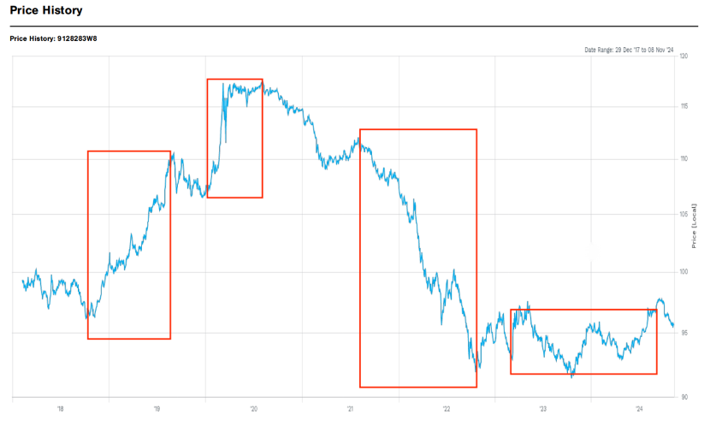
Appendix B
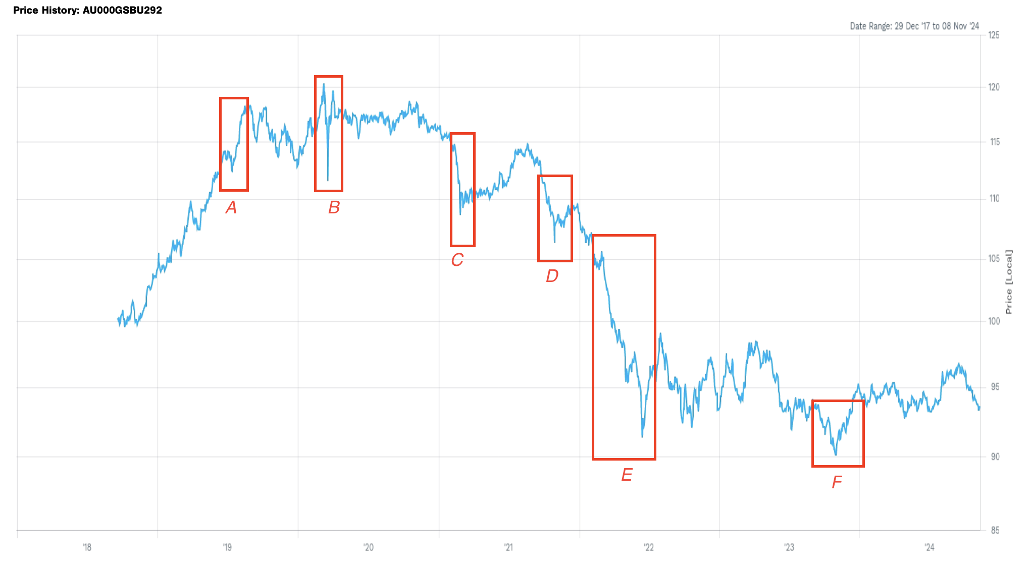

Appendix C:Price of Nvidia Bond (Boerse Frankfurt)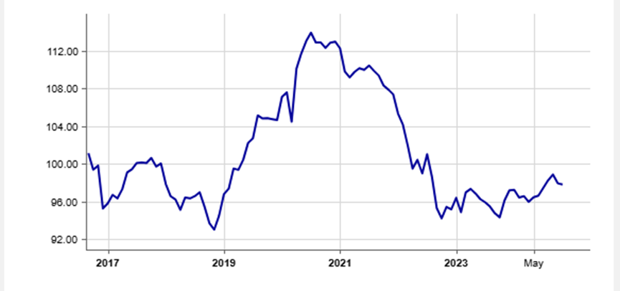
Appendix D: Federal Funds Effective Rate (Federal Reserve Bank of St. Louis)
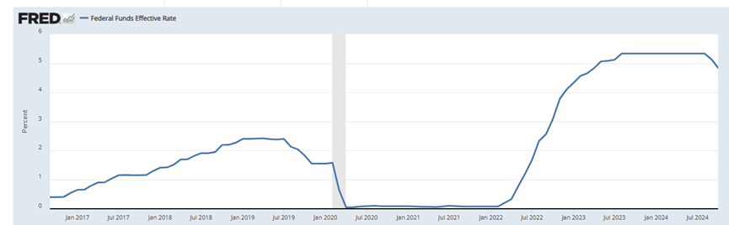
Appendix E: CPI of US (CEIC Data)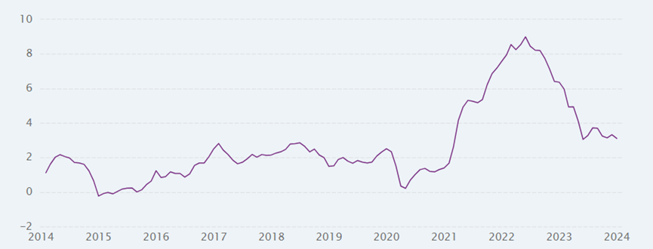
Appendix F: Global GDP Growth (World Bank Group)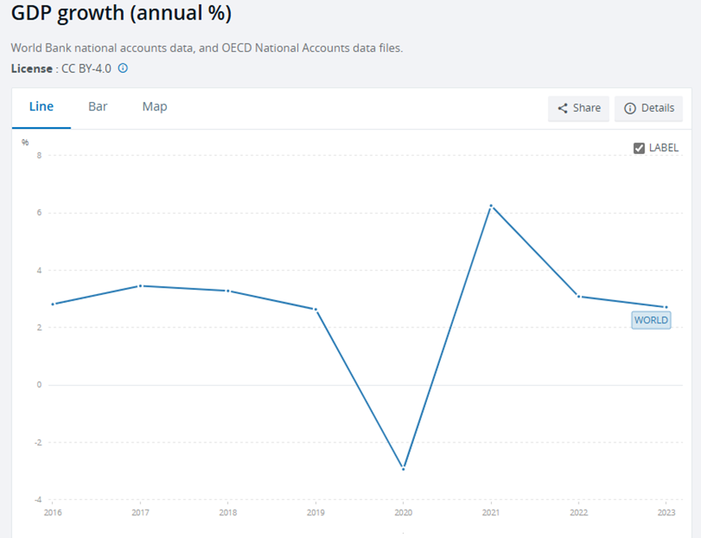
Appendix G: USA GDP Growth (Tradingecnomics)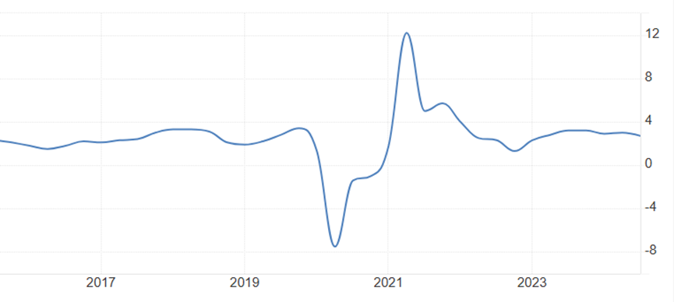
Appendix H: Dollar Index (Tradingecnomics)