

SCHOOL OF BUSINESS
GROUP ASSIGNMENT COVER SHEET
STUDENT DETAILS
Name: Xuan Bach Mai |  |  | Student ID: 22060555
Name: Xuan Loc Nguyen |  |  | Student ID: 22080699
Name: Joel Beauchamp |  |  | Student ID: 22039200
Name: Raza Syed |  |  | Student ID: 22040624
Name: Nick Forrester |  |  | Student ID: 22090477
SUBJECT AND TUTORIAL DETAILS
Subject Name: Financing Enterprises |  |  | Subject code: BUSM1010
Tutorial Group: Group 2 |  | Day: Thursday |  | Time: 3:00-5:00pm.
Lecturer or Tutor name: Dr. Neha Deo
ASSIGNMENT DETAILS
Title: Numerical Problem Solving |  |  | Length: 1625 words
Due Date: 26/5/2023 |  |  | Date submitted: Click or tap to enter a date.
Home campus (where you are enrolled): Western Sydney University Parramatta city
DECLARATION
By submitting your work using this link you are certifying that:
x | You hold a copy of this submission if the original is lost or damaged
x | No part of this submission has been copied from any other student’s work or from any other source except where due acknowledgement is made in the submission
x | No part of this submission has been submitted by you in another (previous or current) assessment, except where appropriately referenced, and with prior permission from the teacher/tutor/supervisor/ Subject Coordinator for this subject
x | No part of this submission has been written/produced for you by any other person except where collaboration has been authorised by the teacher/tutor/ supervisor/Subject Coordinator concerned
x | You are aware that this submission will be reproduced and submitted to plagiarism detection software programs for the purpose of detecting possible plagiarism (which may retain a copy on its database for future plagiarism checking)
x | You are aware that this submission may be de-identified and reproduced in part or in full as an example for future students
 | You will not make this submission available to any other person unless required by the University
Student’s signature: Xuan Bach Mai
Student’s signature: Xuan Loc Nguyen
Student’s signature: Joel Beauchamp
Student’s signature: Raza Syed
Student’s signature: Nick Forrester

Table of Contents

CHANGE IN CONTROL COSTS ........................................................................................ 4
WORKING CAPITAL MANAGEMENT............................................................................ 5
SOURCES OF FINANCE ..................................................................................................... 7
PROFITABILITY OF INVESTED ASSETS ...................................................................... 8
FINAL RECOMMENDATION .......................................................................................... 10
REFERENCES ..................................................................................................................... 11
APPENDIX 1. Profit Margin Ratios .................................................................................. 13
APPENDIX 2. Cash Conversion Cycle .............................................................................. 15
APPENDIX 3. Capital Structure Ratios ............................................................................ 17
APPENDIX 4. Return on Assets ......................................................................................... 19

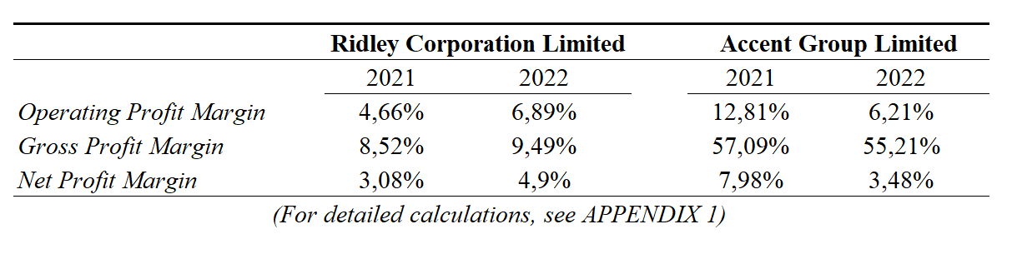
CHANGE IN CONTROL COSTS
Ridley Corporation Limited
The operating profit margin of Ridley Corporation Limited increased from 4.66% in 2021 to 6.89% in 2022. The gross margin has also improved, rising from 8.52% in 2021 to 9.49% by 2022. In addition, the net profit margin was raised to 4.9% in 2022 from 3.08% in 2021.

These positive changes in profit margins suggest enhanced operational efficiency and profitability for Ridley Corporation Limited during the mentioned period. The rise in operating profit margin indicates improved management of operating expenses and increased revenue generation. The increase in gross profit margin implies better control over production costs or potentially higher pricing power. The growth in net profit margin reflects the company's ability to generate a higher percentage of profit from its total revenue after accounting for all operating expenses.

Accent Group Limited
In reverse, Accent Group Limited saw a decrease for all the figures for 2021 and 2022. In 2021, the company had an operating profit margin of 12.81%, which declined to 6.21% in 2022. Similarly, the gross profit margin decreased from 57.09% in 2021 to 55.21% in 2022. The net profit margin also experienced a significant decline, dropping from 7.98% in 2021 to 3.48% in 2022.

The decrease in operating profit margin suggests a decline in efficiency and profitability for Accent Group Limited. The lower gross profit margin indicates a reduction in the percentage of revenue retained after deducting the cost of goods sold, which could be attributed to increased production costs or pricing pressure. The substantial decline in the net profit margin suggests challenges in generating profit after accounting for all operating expenses, including taxes and interest.
WORKING CAPITAL MANAGEMENT
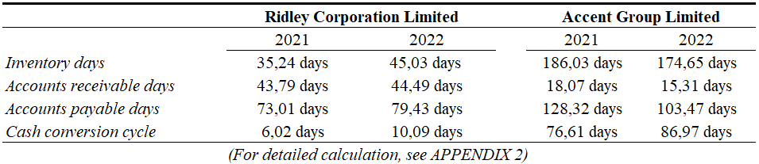

Ridley Corporation Limited
The time between paying for inventory from suppliers and receiving money from sales, or the Cash Conversion Cycle (CCC) of Ridley Corporation Limited, had a substantial increase of 68% from 2021 compared to 2022. The fact that firms are more susceptible to a financial crisis indicates the increased reliance on temporary funding. (Wang 2019).

An analysis of figures in the CCC gives a more detailed description of the reasons for this increase. The inventory days had an increase of 13% in 2022. While this means there is less risk of stock-outs, 'tying up capital in inventory is costly for a firm.' (Bakry 2020). Thereby aiding the increase in working capital.

However, Ridley's accounts receivable and payable days increased by 2% and 9%, respectively. While the accounts receivable had only a slight increase in comparison, which could be due to factors to the broader economy or seasonal factors, the accounts payable had a significant increase. This increase caused the CCC to decrease as there is a reduced direct cost of trade credit associated with any increase in accounts payable.

From this data, the inventory days of Ridley's CCC are the main factor of its increase. Ridley's efficiency in managing its working capital has decreased severely moving into 2022. To remedy this, the inventory management team should implement procedures to lower inventory days, such as improving their coordination with suppliers and production facilities.

Accent Group Limited
Accent's Cash Conversion Cycle has improved as it decreased by 13% from 2021 to 2022, thus decreasing its working capital. Accent's inventory decreased by 16% from 2021 to 2022, depicting a lower cost of holding and decreased working capital. The accounts receivable decreased by 15% in 2022, potentially showing Accent implementing stricter credit terms toward its customers.

Accounts Payable decreased by 19% in 2022, increasing the direct cost of trade credit with suppliers. Accent benefited from this through better discounts from earlier payments. However, as there is no evidence to prove that, the only deduction is that Accent has a lower risk of overdue payment penalties.

Accent shows increased efficiency of its working capital through better inventory management and an earlier collection of cash from its consumers. Delaying payments to suppliers and, decreasing the direct cost of trade credit, increasing accounts payable days would further increase the working capital efficiency. If Accent is not benefitting from the earlier payments it makes in 2022 through discounts, the company should consider implementing methods to increase its accounts payable days.

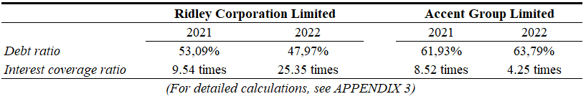
SOURCES OF FINANCE

Ridley Corporation Limited
Ridley's debt ratio decreased from 53.09% in 2021 to 47.97% in 2022. This decrease indicates the company relying less on external sources of finance, potentially reducing the risk of being unable to meet financial obligations on these financial leverages. Due to this decrease in the debt ratio, the interest cover ratio is expected to increase with less debt acquired, and there will be fewer interest expenses.

However, Ridley's increase is extreme. The Interest Cover Ratio went from 9.54 to 25.35 from 2021 to 2022. This drastic increase comes from Ridley's Earnings Before Interest and Tax (EBIT) increasing by 67% while having a 37% decrease in Interest expenses. These values show that Ridley has opted to use more internal sources of finance than external ones, which vastly improved Earnings before tax while not incurring the financial loss of interest expenses.

Accent Group Limited

Accent's debt ratio increased from 61.93% to 63.79%, indicating a shift in the opposite direction. Accent choosing to use more external sourcing of finance. As expected, this increase in external finance sourcing caused a decrease in Accent's Interest Cover Ratio from 8.52 to 4.25 from 2021 to 2022. A possible explanation for this increase in external financing is that with an increase of over 9% in total assets from 2021 to 2022, Accent is looking to expand its business. Even so, Accent must be careful as this comes with more outstanding financial obligations that can become a considerable hindrance if they cannot be repaid.

PROFITABILITY OF INVESTED ASSETS
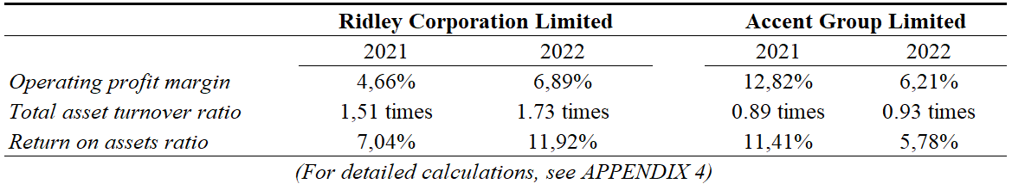

Ridley Corporation Limited
Ridley Corporation Limited has demonstrated strong profitability in its invested capital, driven by increased operating profit. The company's Return on Assets (ROA) ratio rose by 2.23%, indicating that each dollar invested in assets resulted in a 0.0223 increase in operating profit during 2022. This improved profitability can attribute to effective cost control measures, as reflected in the higher operating profit margin. However, as Kovalchuk and Verhun (2019) point out because ROA only reflects the overall company, it is the best reflection. In order to understand the profitability of each component, additional investigation is required.

The company has successfully managed its operating expenses, allowing more sales to retain as profit. Furthermore, the growth in sales revenue by $121,367,000 also contributed to increased profitability. Although total assets remained relatively stable, with a slight difference of $5,695,000, the substantial increase in operating profit explains the percentage rise. Overall, a significant increase in operating profit signifies positive financial performance and enhanced profitability for Ridley Corporation Limited (Bakry, 2020).

Accent Group Limited
Contrarily, Accent Group Limited witnessed a significant decline of 5.63% in Return on Assets (ROA), signifying a 0.0563 reduction in operating profit per dollar invested in assets during 2022. This decline indicates diminished profitability in the company's invested capital. Further examination reveals a significant decrease in the operating profit margin, which plummeted from 12.81% to 6.21% in 2022, indicating ineffective cost control measures.

Although total assets experienced minor changes over the period, the operating profit nearly halved, amounting to $39,214,000. Despite increased sales revenue, profit retention suffered due to marginal expense growth across various aspects. Consequently, Accent demonstrates weak profitability of its invested capital (assets) with a decline in ROA attributed to increased expenses and ineffective cost control.

FINAL RECOMMENDATION
Ridley Corporation Limited should be approved for the loan in light of the improvements in profitability and financial stability and generally stable performance in other areas.

- Cost Management: The figures indicate an increase in the company's profitability. The GPM is still within a reasonable range. Moreover, the company's profitability rose after deducting all costs and taxes.
- Working Capital Management: The data demonstrate that the firm's collection period for accounts receivable is consistent and that it takes longer for inventory to be converted into revenues, which may point to potential problems with inventory management. This shows that the payment terms to suppliers are reliable and less effective at controlling cash flow, perhaps due to longer inventory days.
- Debt Management: The table indicates a reduction in the firm's reliance on debt financing and a better firm's ability to cover interest expenses with its operating income.
- Profitability Of Invested Assets: The data shows that the company is consistently producing a certain level of sales concerning its entire assets, and its ability to make money from its assets has improved.

Accent Group Limited should not be approved for the loan regarding its capacity to pay its financial obligations and turn a profit, given the decline in profitability, rising debt levels, and reduced interest coverage.

- Cost Management: The data suggests that the company's profitability has significantly decreased. Even though the fall of GPM is modest, it nonetheless reflects a decline in the firm's gross profit profitability. This shows a sharp fall in the company's profitability, including all costs and taxes.
- Working Capital Management: Even while the inventory holding duration is decreasing, it is still high, suggesting possible problems with inventory management and possibly tying up working capital. The firm's receivables collection period indicates a more substantial capacity to collect client payments. This suggests that the payment terms to suppliers are getting shorter, which might help with cash flow management. CCC proves a decline in the company's capacity to transform its resources into cash flow effectively.
- Debt Management: The table suggests a greater reliance on debt financing, which might raise financial risk, and it reduces the ability to pay interest costs out of operational profits, thus raising questions about its ability to service debt.
- Profitability Of Invested Assets: Data shows that there has yet to be a significant shift in the company's capacity to generate sales with its overall assets and a sharp drop in the company's capacity to turn a profit from its assets.

REFERENCES

Bakry, W (ed.) 2020, Financing enterprises, 2nd edn, Pearson, Melbourne, Australia.

DatAnalysis Premium 2021a, Redley Corporation Limited, company financial report, viewed 26 April 2023, DatAnalysis Premium database.

DatAnalysis Premium 2021b, Accent Group Limited, company financial report, viewed 26 April 2023, DatAnalysis Premium database.

DatAnalysis Premium 2022a, Redley Corporation Limited, company financial report, viewed 26 April 2023, DatAnalysis Premium database.

DatAnalysis Premium 2022b, Accent Group Limited, company financial report, viewed 26 April 2023, DatAnalysis Premium database.

Kovalchuk, T & Verhun, A 2019, ‘Improvement of the method of analysis of asset management
efficiency’, Baltic Journal of Economic Studies, pp. 61-66, viewed 17 May 2023.

Wang, B 2019, ‘The cash conversion cycle spread’, Journal of Financial Economics, pp. 472-497, viewed 17 May 2023.

