What is GMX?
GMX launched initially as Gambit Financial on the Binance Smart Chain (BSC), rebranded in September 2021 and has since evolved into a fully on-chain, decentralized exchange (DEX) that supports spot trading and perpetual futures with up to 100x leverage. Designed to offer ultra-low swap fees and minimal price impact. GMX distinguishes itself from centralized exchanges by allowing users to trade directly from their crypto wallets by connecting; it doesn't require KYC or any regulation, which helps maintain full custody of customer assets.
The platform initially deployed on Arbitrum One, a Layer 2 scaling solution for Ethereum, and subsequently expanded to Avalanche in January 2022, a smart contract blockchain compatible with the Ethereum Virtual Machine (EVM). After the proposal to bring the GMX V2 to Solana in May 2024, the exchange was expanded to Solana in March 2025 (Appendix 1). The protocol developers remain anonymous, but two people who can sign the project's multi-signature wallet are Krunal Amin, founder of UniDex, and Benjamin Simon, co-founder of Stealth Crypto.
What does GMX do / what problem is GMX trying to solve?
Most crypto assets and derivatives trading happens largely on centralized exchanges like Binance and Coinbase. This is mainly because they are usually the entry point for a new user (enabling the fiat to crypto on-ramp) and provide intuitive and responsive UX. This generally results in users sticking to the same platform and not shifting to a decentralized, on-chain alternative. However, increasing on-chain activity, token launches and the rise of the DeFi ecosystem in general, along with growing regulatory concerns on centralized exchanges.
The success of Uniswap, however, has spawned many copycat projects. Perpetual trading protocols are still nascent. This leaves a gap in the market for an on-chain protocol that supports both spot and perpetual as most centralized exchanges, which is also profitable for token holders. GMX aims to fill and capitalize on this gap in the market, and with trading activity continuously increasing on-chain, it is well positioned to become the “on-chain Binance”. With a unique token incentive structure and sophisticated features, GMX is difficult to copy or 'fork', which is not the case with simple spot DEXes; this gives GMX an edge in the market.
Although the competition in the decentralized spot/perpetual markets is growing, GMX has managed to carve out a special place amidst the rising competition through its novel protocol mechanics and tokenomics. The GLP liquidity pool model enables traders to perform zero-slippage trades, unlike Uniswap’s AMM model, which requires traders to incur some slippage on swaps. GMX uses the GLP pool and dynamic price feeds provided by Chainlink to ensure accurate and dynamic price feeds by aggregating data from major exchanges, enhancing reliability, and reducing manipulation risks.
Decentralization of GMX and its token use case
The GLP liquidity pool used for swap assets and go long/short on them is one of the significant innovations on the platform. GMX does not operate an order book. Other competitors, notably dYdX, operate off-chain order books, but GMX uses its multi-asset pool to fulfil orders. Two primary types of derivative DEX AMMs are hybrid AMMs and stable AMMs. It consists of highly liquid assets and stablecoins (ETH, BTC, UNI, LINK, stablecoins, etc.), thereby reducing oracle‐price variance while still covering the sector’s blue‐chip breadth, which the liquidity providers can deposit to the pool and, in exchange, mint GLP tokens on the same. Since the pool does not utilize the traditional AMM model, LPs providing liquidity also don’t have to worry about impermanent loss. The GLP pool then serves as the counter‐party to traders, as its providers gain when traders lose and vice versa—delivering deep, instantly available liquidity for every transaction. A fee is incurred for minting GLP tokens. This fee goes lower the higher the demand for that particular asset in the pool is, and users can also burn GLP tokens to redeem any of the assets in the pool, according to the dollar-denominated value of both GLP and the asset to be redeemed (1:1) - minus some fees. Unlike traditional margin trading, where users borrow assets to go short and stablecoins to go long, users on GMX borrow assets to go long and stablecoins to go short. This means that GLP holders are renting out their spot exposure to traders.
Users who mint GLP supply this liquidity and automatically receive 70% of the protocol’s trading fees, all while avoiding the impermanent‐loss risk typical of many pools. The other 30% will be distributed to staked GMX holders; depending on the network the user staked, they will receive AVAX or ETH. The GMX tokens accrue value mainly through being staked, which is why roughly 63% of the total circulating supply has been staked (Appendix 2).
The GMX token is the governance token for the GMX protocol; by staking GMX, users will receive escrowed GMX (esGMX), which can be staked again for a reward similar to normal GMX or vested to become standard GMX tokens over one year. Even though the total supply is 13.25 millions, 2 millions are reserved for emissions arising from staking esGMX, which may not even be completed, making GMX extremely scarce (Appendix 3). GMX token holders can vote on changes to the GMX protocol. This has shown the importance of the token for this project, as users need to buy the token to participate and be a part of the project, and GMX cannot run with the token.
Strengths and weaknesses of the application
GMX has two versions, V1 and V2. Initially, V1 was created with zero price impact, which was very beneficial to large investors as it allowed them to keep their capital on the exchange for a long time, potentially saturating trading capacity and leading to a skew in open balances. This version also failed to balance open interest and unutilized capital, which not only represented an opportunity cost for liquidity providers but also potentially limited the overall efficiency of the platform. GMX introduced GLP, but it was too complex for investors; the skyrocketing trading volume exposed the weaknesses of this version and showed the need to scale to match the demand. That is why GMX released V2, introducing isolated liquidity GM pools, a solution to solve the problems. These GM pools can help liquidity providers offer any asset the DAO allows. In addition, GMX V2 supports a lot of tokens, and if a token has enough liquidity, listing will be easier (Appendix 4).
The Oracle Priced AMM model GMX uses provides a simpler liquidity mechanism than CLOBs, allowing users, not just market makers, to earn transaction fees. This model offers a higher level of transparency and decentralisation because order books require a lot of computational resources, are often a hybrid system combining off-chain and on-chain, and are heavily dependent on market markers, especially in the early stages. However, that is also the weakness of GMX; CLOBs have their advantages because, through CLOBs, users can see buyers and sellers, which can save certain costs. Furthermore, CLOBs allow unrestricted price discovery right on the platform without relying on external sources' liquidity. Although arbitrageurs can exploit this, CLOBs are less limited than oracle-based AMMs. Finally, CLOBs can provide faster execution since frontrunning is more difficult or impossible in some designs.
Although GMX conducts regular security audits and sets up bug bounties, the multiple connections of DeFi protocols make it difficult to eliminate the risk of cross-protocol attacks. For example, GMX relies on Chainlink Oracle to provide price data. If the oracle is manipulated (such as a flash loan), it may lead to incorrect clearing or price manipulation. In addition, the multi-asset hybrid model of GLP pools in GMX may also increase the risk of vulnerabilities in complex contracts. A successful smart contract vulnerability attack (even if the contract is not invaded) may instantly deplete GLP liquidity pool funds and directly destroy protocol solvency.

Liquidity providers (LPs) earn 70% of protocol fees by holding GLP tokens but must bear counterparty risk. If the market remains in a bear market for a long time, traders' sustained profits may lead to losses for LPs, triggering liquidity outflows; Stablecoins account for approximately 33% of the GLP pool (such as USDC and USDT). If the market experiences severe fluctuations leading to stablecoin detachment or runs may trigger a liquidity crisis. Liquidity is the lifeline, and once there is a liquidity crisis, the following situations will occur, forming irreversible negative feedback (Appendix 6).

GMX is developed by an anonymous team, and while it aligns with DeFi's decentralized philosophy, it may also become a target of regulatory crackdowns. Moreover, the GLP pool contains centralized stablecoins such as USDC. If the issuer is subject to regulatory sanctions (such as freezing addresses), this may directly impact the liquidity structure of GMX (Appendix 7).

All the versions of GMX have been audited. For V1, ABDK and Quantstamp provided audit reports. For V2, GMX gets audited by ABDK, Certora, Dedaub, Guardian, and Sherlock, with the latest audit being 5 months ago. The increase from 2 to 5 audit firms indicates that GMX is paying more and more attention to its protocol security, and the complexity of the protocol, the amount of funds, and user trust are all synchronously improving. With the latest version of GMX on Solana, the project got audited from Sherlock and Zenith also. Compared to Hyperliquid, with only 8 developers and 15 commits, GMX has around 15 monthly developers with 286 commits to the project. This is considered a good point, as the exchange can operate well with continuous upgrades in the future. However, GMX may need more development activity with new features as the competition between decentralized perpetual exchanges to attract users is getting more competitive with other big players, such as dYdX, Synthetix and new players will join and take the market share.

How may GMX fail in the future?

Firstly, decentralized platforms rely on public blockchains, which can experience congestion, high gas fees, and slow transaction times during peak demand. Although GMX uses layer 2 networks like Arbitrum and Avalanche to mitigate this, the issue is still a factor when compared to centralized exchanges.

Secondly is smart contract risk, without centralized oversight, the entire platform depends on the integrity of its code. If vulnerabilities exist in smart contracts, they can be exploited, potentially leading to loss of funds. On 26th March, 2025 Abracadabra’s Cauldron exploited led to a loss of 13 millions dollar and the issue was confined to the integration with GMX V2, which uses GMX’s liquidity pools for their operations. Although clarified that its contracts were secure, it also rings an alarm bell that there could be a future exploit directly to GMX if the hacker can find errors in the smart contract.

Lastly is market manipulation. On 20th September, 2022, GMX suffered an attack on their AVAX perps as someone bought the perp, then moved the underlying price on Binance to sell and repeat, it means that if tokens trading on GMX could be manipulated, people can take this as an advantage and exploit the pool on GMX. Moreover, it also proves the problem about oracle and the lack of slippage on GMX trades, if GMX have right slippage parameters, this attack won't be possible. By that GMX should improve or listen to the users to adjust this feature as slippage may hurt active traders but will benefit liquidity providers.

References

https://github.com/gmx-io/gmx-synthetics/tree/main/audits

https://github.com/gmx-io/gmx-contracts/tree/master/audits

https://defillama.com/protocol/gmx

https://defillama.com/protocol/hyperliquid

https://defillama.com/protocol/dydx

https://github.com/zenith-security/reports/blob/main/reports/GMX%20Solana%20Protocol%20-%20Zenith%20Audit%20Report.pdf

https://x.com/GMX_SOL/status/1884271077716533454

https://gov.gmx.io/t/gmsol-bringing-gmx-v2-to-solana-and-realizing-the-trinity-of-decentralized-leverage-trading/3430

https://cryptorank.io/price/gmx

https://x.com/kesterwu/status/1658852703093633025/photo/1

https://x.com/jayantkrish/status/1571893643178569728?s=20&t=O--bs-V1Xnkmzm2JZOdZsw

https://cryptopotato.com/gmx-defends-contracts-after-13-million-loss-tied-to-abracadabras-cauldron-exploit/

Appendix
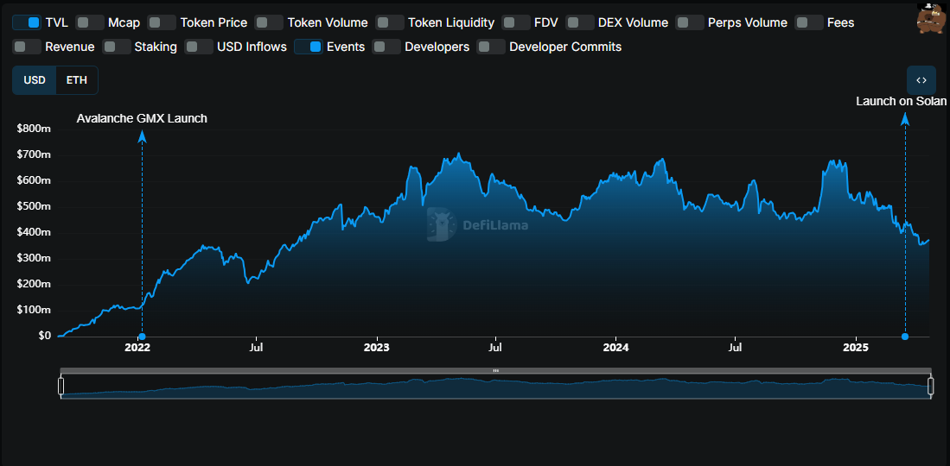
Appendix 1

Appendix 2

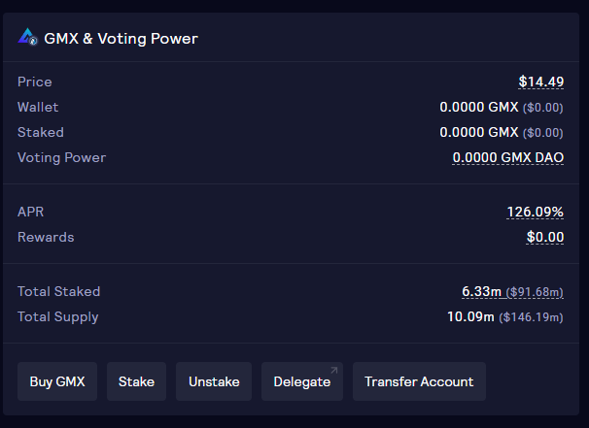
Appendix 2
Appendix 3

Appendix 4
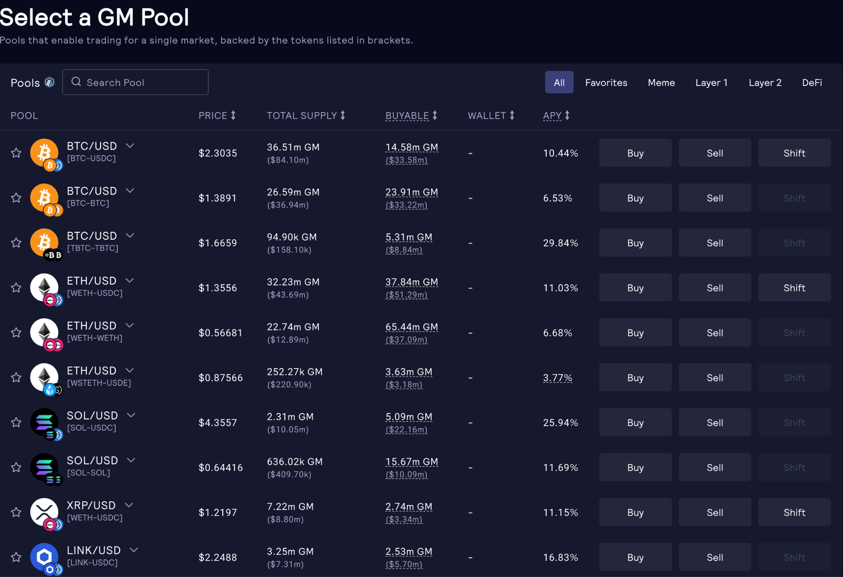

Appendix 5

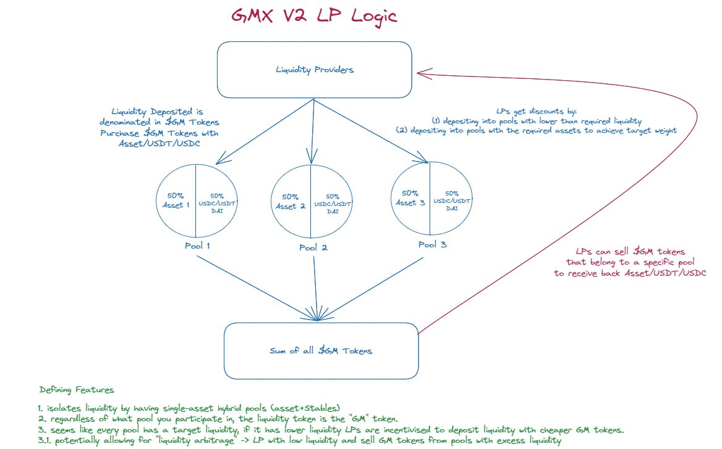

Appendix 6
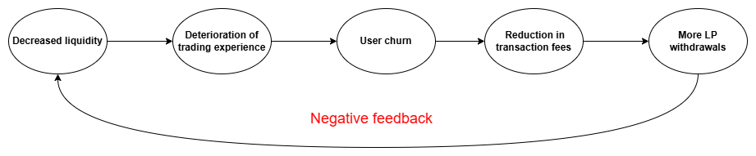

Appendix 7
