
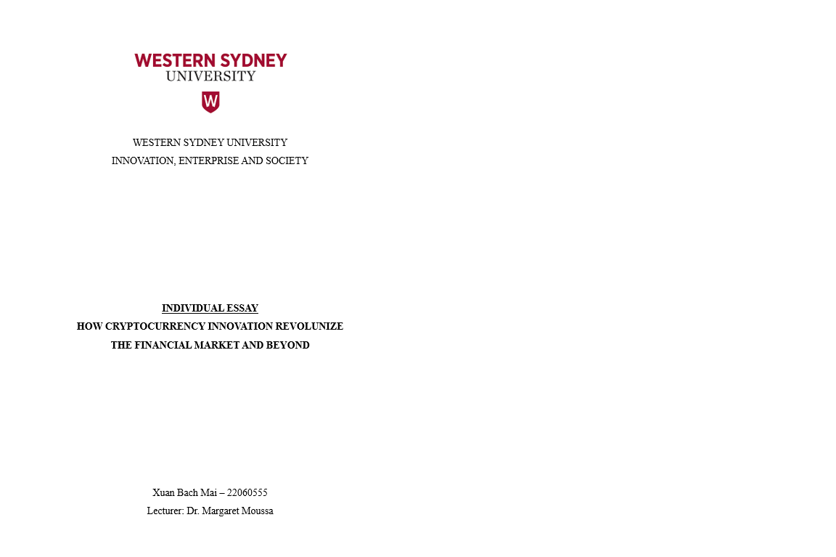
After the global financial crisis occurred in 2008, the appearance of Bitcoin or cryptocurrency innovations driven by blockchain technology has entirely changed how the finance industry works. This essay will detail the impact of cryptocurrency by analyzing key innovations, why it should be widely adopted, broader social and economic trends and future implications for professional practice. Together with concepts such as creative destruction, accumulation and crisis, and the transformation of social relations, we can understand the revolution in finance after the appearance of cryptocurrency.

With the rise in dissatisfaction with the traditional banking system, known for its centralized control and high transaction costs (Kabadayi, 2016), the demand for decentralized alternatives has increased significantly. With all the factors and thanks to the recent technological advancement in blockchain technology, cryptocurrency was born with high security and transparency. A fundamental movement trend towards decentralization and digitization illustrates a change in society and the economy as cryptocurrency gets more and more popular. With modern technology, people can quickly access services that suit their financial needs and proactively manage their assets. Furthermore, trust in the traditional finance system was eroded after the financial crisis, and the interest changed to other alternative currencies and investment possibilities (Gudgeon, 2020).. The implementation of blockchain or cryptocurrency innovation can apply to the supply chain by changing the monitoring process and confirming a product until it reaches its destination. Just like, with the formation of companies such as Netflix or Microsoft, the entertainment and software industries were transformed and reshaped forever. That is why cryptocurrencies can make a difference not only in finance, supported for Schumpeter's disruptive innovation

However, this disruption directly affects the existing advantage structure and operation in many developed countries, which coincides with Marx's criticism of capitalism's tendency to centralize wealth and consequences in small groups. Moreover, according to Weeks's view, with the change in social relationships, the collaborative aspect of this innovation can also disrupt the present power structures and encourage increased financial involvement for everyone. Thus, not only direct financial effects, cryptocurrency also signifies a significant shift in societal values toward decentralized, cooperative in various fields, including governance, identity, and trust beyond just finance.

Some outstandingly performed cryptos, like Bitcoin and Ethereum, are creating huge impacts on established financial institutions through decentralized and transparent solutions, which deals with how cryptocurrency undermines the existing financial intermediaries and the new investment opportunities it offers (Philip, 2023). With many online platforms and protocols, the decentralized finance summer in 2017 is one of the best examples of the creative destruction from Joseph Schumpeter because it shows financial services in a unique way that differs from what banks provide. Raphael (2023) explained that DeFi protocols allow a person to lend money by interacting directly and trade automatically or yield farming to create profit. It puts more money under the control of its owners and removes any need for intermediaries. The high yield return from cryptocurrency has also led to a massive increase in business activities and start-ups. People use blockchain technology to build new applications and develop innovative business management methods. Non-fungible tokens and decentralized autonomous organizations are some of the new definitions and use cases in the cryptocurrency space, as these ideas never stop pushing limits towards what can be done in this field.

However, the speculative character and decentralized environment are the reasons that bring about concerns about Karl Marx's accumulation and crisis, harping on effective risk management and regulation. Cryptocurrencies have changed the social nature of institutions, just the way it was theorized by Weeks. Many cryptocurrency projects promote collaboration and inclusivity, offering a new path to economic equality by reshaping power dynamics and challenging traditional governance norms in financial transactions. Growth in cryptocurrency is not only about money; it reveals more profound societal and economic change towards freedom, openness, and technological advancement. Blockchain technology, most significantly, improves efficiency, security, and transparency across disciplines, including health and supply chain management. It will be a good fit for industries that need record-keeping, which can safely be done and efficiently provided to the auditor. In this way, excellent qualities are imbued in it: transparent, immutable, and secure.

Further developments in cryptocurrency technology and regulations can provide more and more transformations and innovations in the financial market. The potential consequences of cryptocurrencies becoming embedded in traditional financial systems include disrupting customary banking models and emerging avenues for investment and fundraising. By that, emerging decentralized finance platforms in underserved areas may help democratize financial access. From Schumpeter's point of view, entrepreneurs play a crucial role in pushing cryptocurrencies to be added to the regular banking system. They innovate new tactics in business, develop unique financial products, and challenge the traditional norms, therefore redesigning the industry's competitive landscape. Financial business professionals must undergo a sea change in their operations to accommodate the use of cryptocurrencies. Bankers, financial analysts, and investment managers must adjust to cryptocurrency innovations' explosive effects (Kayani, 2024). However, entrepreneurship is just one of the factors noted by Marx and Weeks that go into professional employment; other causes are deeper in societal change. Wealth and power accumulation in cryptocurrencies in a society can exaggerate inequalities and divisions, and in the same way, Marx argues that there are inherent contradictions within capitalism. Weeks elucidates the connection between capitalism and the transformation of social relationships, giving birth to diverse power structures and social hierarchies within the cryptocurrency community. Cryptocurrencies can improve fairness in financial services, and they also give rise to apprehensions over governance, responsibility, and the allocation of wealth among first adopters and persons with privileged information.

Cryptocurrency has had a colossal impact not only on the financial sector but also on other domains. Therefore, industries need to catch up with the changing environment, understand blockchain technology, abide by regulatory provisions, and deal with security issues of cryptocurrency transactions. It has brought investment professionals to a whole new set of challenges and opportunities, considering and managing volatile and speculative cryptocurrencies. Professionals in the financial sector must rapidly adapt to the changing environment through a complete understanding of blockchain, the practical overcoming of regulatory challenges, and the acceptance of new ideas with an open mind. The difficulties for investment professionals are new in assessing and managing cryptocurrencies due to their legal and compliance specialists needing to understand the changing legislation and reduce associated risks (Lescrauwaet, 2022).

This is what creative destruction promises for the future of crypto; it will evolve and change. Look at the array of ongoing ecosystems that cryptocurrencies enable, like various blockchain-driven DeFi platforms, NFT markets, and blockchain-powered governmental systems. Karl Marx had much to say concerning the contradictions at the heart of capitalism; one of them lies within its very nature and essence. Cryptocurrencies pose risks and challenges, indicating the necessity for change, which could alter situations completely. However, they might only be realized in practice sometimes, given prevailing attitudes towards money as demonstrated by various types. At the same time, the accumulation of wealth through the control of cryptos may exacerbate economic gaps, thus leading to violent disturbances, instability or conflict among people on a global scale. Both continuous technological innovation and regulation can be the course for future cryptocurrency innovation in finance. In this evolving world, finance professionals and organisations must participate in education, rule-making, and risk management.

Furthermore, how social connections diversify in a capitalist society, as described by Weeks, means that the cryptocurrency sector has to take heed of inclusion, diversity, and equity. Moving ahead, its actors will have to be eternally vigilant on these issues for the industry to make the fruits of cryptocurrency innovations filter across the entire spectrum of society. Considering its social and economic effects, financial institutions must adopt cryptocurrency innovation to adapt to the future. By applying Schumpeter's concept, companies should create a culture encouraging entrepreneurship and innovation, inspiring workers to experiment with fresh ideas and explore new technologies. However, in the words of Marx and Weeks, companies must analyze cryptocurrency innovations’ broader social impacts, which calls for a fuller understanding of how cryptocurrency works, i.e. patterns of financial flows, social exchanges and power games inside and outside the organization. With effective management that considers all the ideas of Schumpeter, Marx and Weeks in their decision-making and strategic planning processes, organizations can overcome risk reduction and social problems and utilize innovation and growth within the cryptocurrency landscape.

Overall, this leads us to the conclusion that cryptocurrency innovation can also be considered a paradigm shift from the disruptive perspective. It is fundamentally an innovation that challenges the entire status quo from within the financial market. It develops modern social communications and, by extension, modifies general macroeconomic trends. A profound understanding of the impact of this economic revolution on professional practice and industry development is made possible by examining cryptocurrency through several theoretical lenses.

References
- Kabadayi, S. (2016). Customers’ dissatisfaction with banking channels and their intention to leave banks: The moderating effect of trust and trusting beliefs. J Financ Serv. https://doi.org/10.1057/s41264-016-0005-2

- L. Gudgeon, D. Perez, D. Harz, B. Livshits and A. Gervais. (2020). "The Decentralized Financial Crisis," 2020 Crypto Valley Conference on Blockchain Technology (CVCBT). doi: 10.1109/CVCBT50464.2020.00005.

- Phillips, Peter & Pohl, Gabriela. (2023). Bitcoin, Creative Destruction, and the Existing Order. 10.13140/RG.2.2.33392.12805.

- Li, Sen & Chen, Yan. (2022). How Non-Fungible Tokens Empower Business Model Innovation. Business Horizons. 10.1016/j.bushor.2022.10.006.

- Raphael, Bernhard, Pietro and Friedhelm, Victor. (2023). The Technology of Decentralized Finance (DeFi). https://www.bis.org/publ/work1066.htm

- Kayani U, Hasan F. (2024). Unveiling Cryptocurrency Impact on Financial Markets and Traditional Banking Systems: Lessons for Sustainable Blockchain and Interdisciplinary Collaborations. Journal of Risk and Financial Management. https://doi.org/10.3390/jrfm17020058

- Lescrauwaet, Lyytinen & Wagner, Hekkert & Yoon, Cheng & Shukla, Sovacool. (2022). Adaptive Legal Frameworks and Economic Dynamics in Emerging Tech-nologies: Navigating the Intersection for Responsible Innovation. Law and Economics. 10.35335/laweco.v16i3.61.

